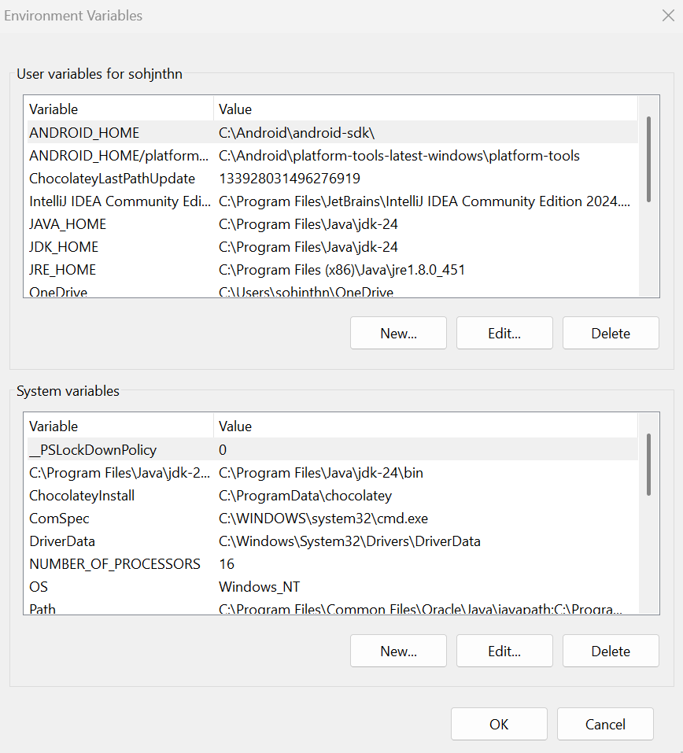

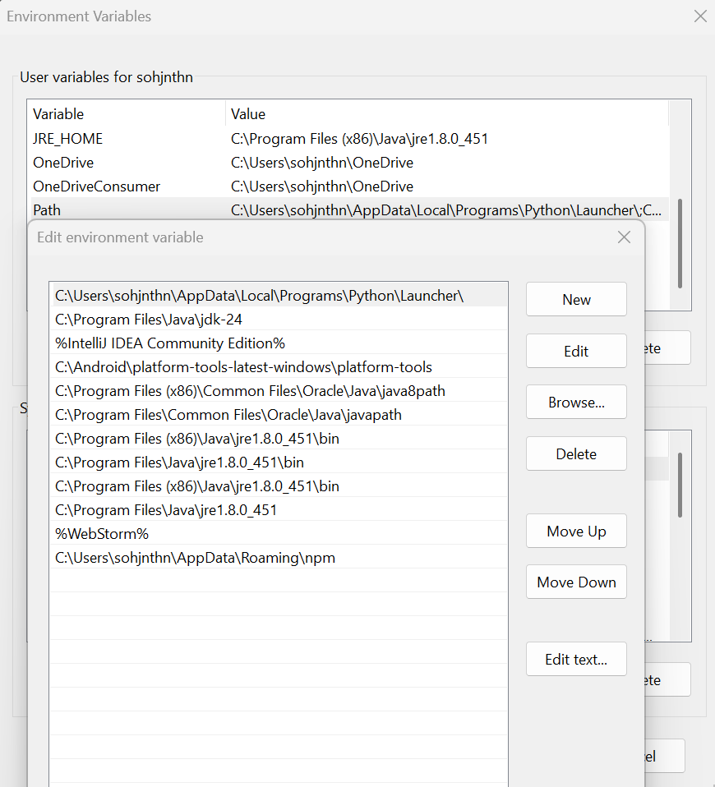

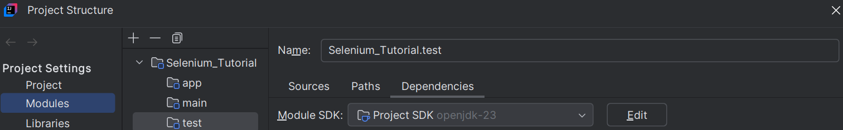

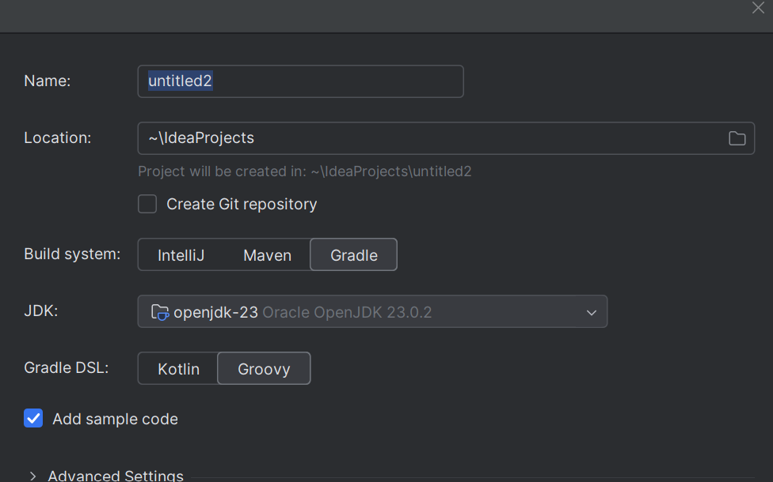

testng.xml

<!DOCTYPE suite SYSTEM "https://testng.org/testng-1.0.dtd">
<suite name="Cucumber Test Suite" parallel="false">
<!-- Note: The testng.xml file for the package name, should be
within the package folder, to avoid the red line error.-->

<!-- Replace with your "packageName.mainJavaClassNameWithoutDotJava" for running the
related Given, When, Then methods (via the Selenium Documentation page
object model (non-main) Java classes' Java Objects);

1) The number of (non-main) Java classes for the three groups of websites
is *three* in total for the Given, When, and Then methods of the main Java
class TestDesktopWebsites.java respectively; or

2) The number of (non-main) Java classes for the three smartphone
applications is *three* in total for Given, When, Then of the main Java
class TestAndroidApps.java, for which the Given and When methods each use one
object of first (non-main) Java class' object respectively, and the Then method
used one object each of the second and third (non-main) Java classes -->
<test name="Cucumber TestDesktopWebsites">
<classes>
<class name="hellocucumber.TestDesktopWebsites"/>

</classes>
</test>
<!-- Additional note: As Selenium_Android is from another IntelliJ IDEA (Community)
Project, and the related files were copied from Selenium_Android, the filepath
is not allowed to use Selenium_Tutorial (this project)'s Selenium_Screenshot_Images
folder. This applies to all four Selenium_Android Java files' bottom of the
"public static String takeScreenshot(WebDriver driver) throws IOException" method(s).
Therefore, the Selenium_Screenshot_Images folders for Selenium_Tutorial and Selenium_Android
do not contain the other project's screenshot images respectively. -->
<test name="Cucumber TestAndroidApps">
<classes>
<class name="hellocucumber.TestAndroidApps"/>
</classes>
</test>
<!-- Observation:

Both "Spark" ExtentReports reached the target folder of the Selenium_Tutorial project.
The App ExtentReport was created about 1 minute after the Desktop Website ExtentReport.

As compared to running each project's respective feature files
separately via each project, running both features together in a suite keeps having
errors frequently.

For the case of the first, and third smartphone applications which were used, we need
to be able to click on the permission buttons (which cannot be detected by
the Appium Inspected Weblink) once, in time. Clicking twice means the related test for
the Then method of the main Java class TestAndroidApps.java would fail.
-->
</suite>

Selenium_Tutorial.feature
Feature: Learning Google Chrome desktop web browser automation with IntelliJ Idea,
Java, Selenium, and Cucumber

Scenario: How to find WebElements which cannot be found with name, id, className,
and partialLinkText
Given that the easiest way to find WebElements is by driver.findElement; and driver.findElements which returns a List WebElement
When it is not possible to do so for certain WebElements in this way
Then we use driver.findElement By.tagName"...", for which ... can be i for <i> or button for <button>

Selenium_Android.feature
Feature: Learning Android smartphone application automation with IntelliJ Idea,
Java, Selenium, and Cucumber

Scenario: How to find the WebElements with Appium Inspector Weblink via By.xpath
Given I wish to learn how to automate a smartphone application which can be used for a real Android 15 device
When I provide the Given and When methods with a new object of the first non-main class
Then I provide the Then method with the new objects of the second and third non-main classes

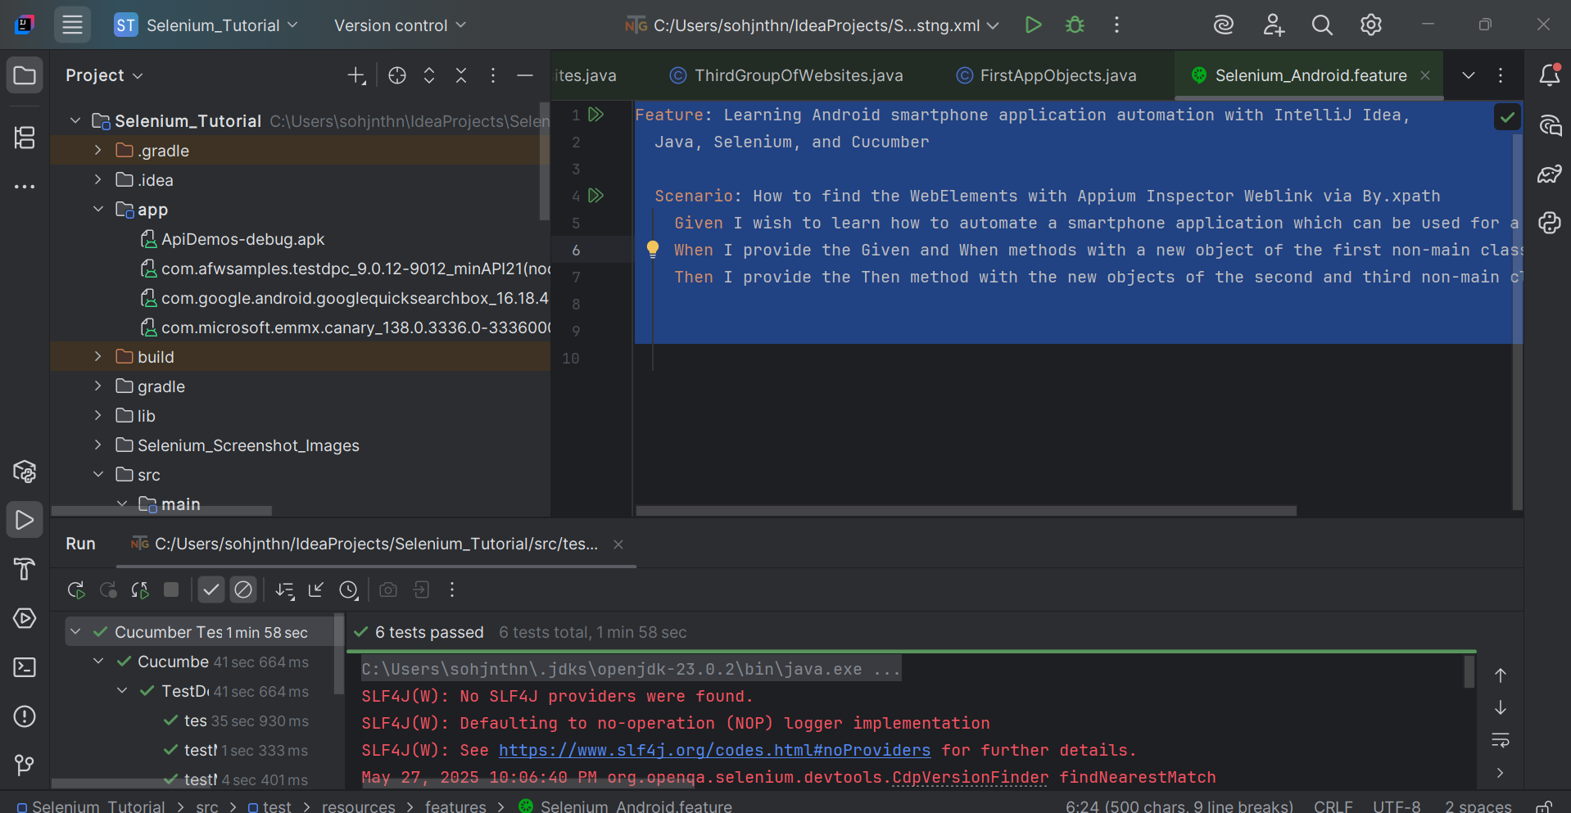

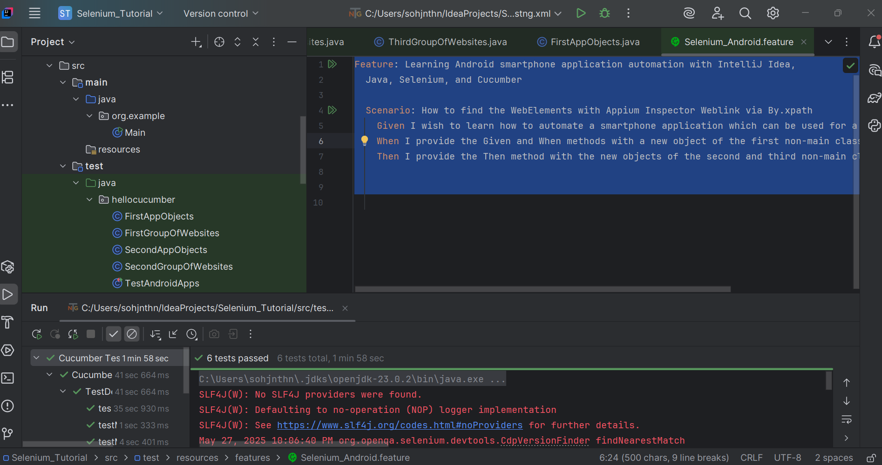

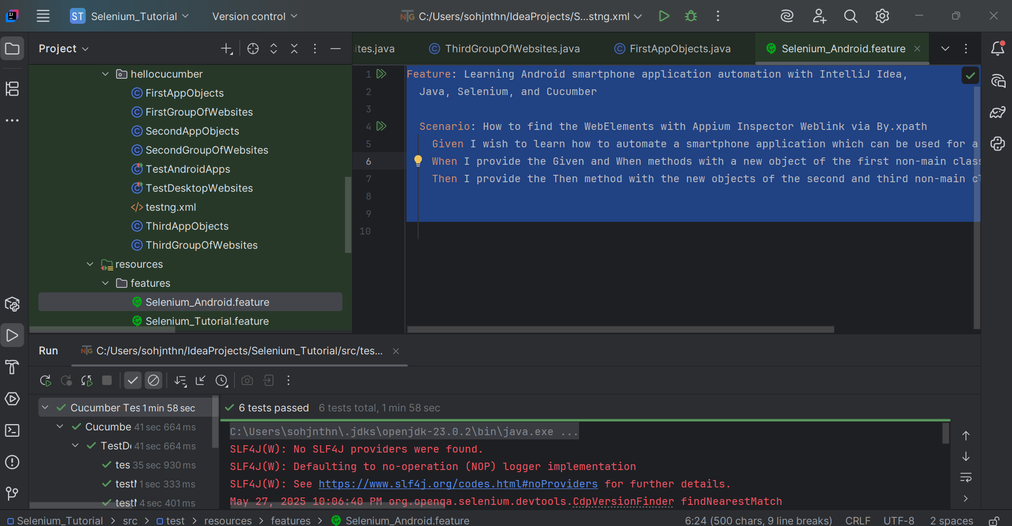

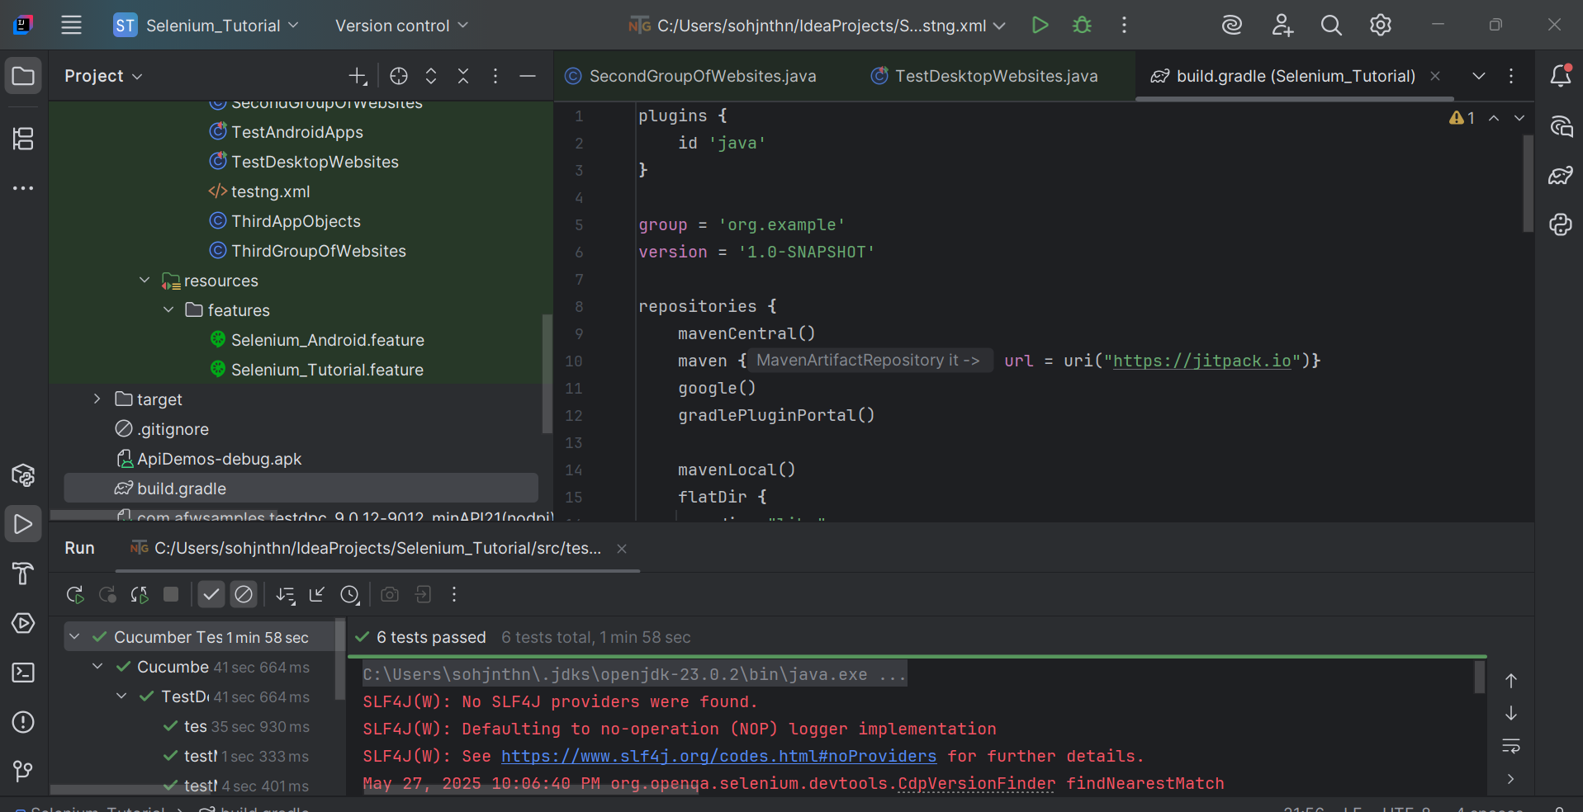

build.gradle
plugins {
id 'java'
}

group = 'org.example'
version = '1.0-SNAPSHOT'

repositories {
mavenCentral()
maven { url = uri("https://jitpack.io")}
google()
gradlePluginPortal()

mavenLocal()
flatDir {
dirs "libs"
}
}

dependencies {
implementation 'io.cucumber:cucumber-testng:7.22.2'
implementation 'org.testng:testng:7.11.0'
implementation 'io.appium:java-client:9.4.0'
implementation 'io.cucumber:cucumber-junit:7.22.1'
implementation 'org.junit.jupiter:junit-jupiter-api:5.12.2'
implementation 'org.junit.jupiter:junit-jupiter-engine:5.12.2'
implementation 'io.cucumber:cucumber-core:7.22.1'
implementation 'io.cucumber:cucumber-spring:7.22.1'
implementation 'org.apache.groovy:groovy-all:4.0.26'
implementation 'io.cucumber:cucumber-gherkin:7.22.1'
implementation 'io.cucumber:gherkin:32.1.1'
implementation 'io.cucumber:gherkin-utils:9.2.0'
implementation 'io.cucumber:cucumber-jvm-groovy:6.10.4'
implementation 'io.cucumber:cucumber-groovy:6.10.4'
implementation 'io.cucumber:cucumber-java:7.22.1'
implementation 'org.seleniumhq.selenium:selenium-chrome-driver:4.32.0'
implementation 'com.aventstack:extentreports:5.1.2';
implementation 'org.springframework:spring-beans:6.2.6'
implementation 'org.springframework:spring-core:6.2.6'
implementation 'org.springframework:spring-web:6.2.6'
implementation 'org.springframework:spring-test:6.2.6'
implementation 'org.springframework:spring-webmvc:6.2.6'
implementation 'org.springframework:spring-jms:6.2.6'
implementation 'org.springframework:spring-messaging:6.2.6'
implementation 'org.springframework:spring-aop:6.2.6'
implementation 'org.springframework:spring-orm:6.2.6'
implementation 'org.springframework:spring-context-support:6.2.6'
implementation 'org.springframework:spring-context:6.2.6'
implementation 'org.springframework:spring-tx:6.2.6'
implementation 'org.springframework:spring-jdbc:6.2.6'
}

test {
useJUnitPlatform()
}

TestDesktopWebsites.java
package hellocucumber;

import io.cucumber.testng.AbstractTestNGCucumberTests;
import com.aventstack.extentreports.ExtentReports;
import com.aventstack.extentreports.ExtentTest;
import com.aventstack.extentreports.MediaEntityBuilder;
import com.aventstack.extentreports.Status;
import com.aventstack.extentreports.reporter.ExtentSparkReporter;
import io.cucumber.java.en.Given;
import io.cucumber.java.en.Then;
import io.cucumber.java.en.When;
import io.cucumber.junit.Cucumber;
import io.cucumber.junit.CucumberOptions;
import io.cucumber.spring.CucumberContextConfiguration;
import org.junit.runner.RunWith;
import org.openqa.selenium.OutputType;
import org.openqa.selenium.By;
import org.openqa.selenium.Keys;
import org.openqa.selenium.WebDriver;
import org.openqa.selenium.WebElement;
import org.openqa.selenium.TakesScreenshot;
import org.openqa.selenium.chrome.ChromeDriver;
import org.openqa.selenium.io.FileHandler;
import org.testng.annotations.Test;

import java.io.File;
import java.io.IOException;
import java.util.List;
import java.time.LocalDateTime;
import java.util.Objects;

//TIP To <b>Run</b> code, press <shortcut actionId="Run"/> or
// click the <icon src="AllIcons.Actions.Execute"/> icon in the gutter.

@CucumberContextConfiguration
@RunWith(Cucumber.class)
@CucumberOptions(
// features should start with "src/test/resources/features/xxxxxxxxxxx.feature",
features = "src/test/resources/features/Selenium_Tutorial.feature",
// glue starts with "src/test/java/#package for the Test Java class with the Given;When;Then annotations#/",
glue={"src/test/java/hellocucumber/"},
// plugin = = {"pretty", "html:target/cucumber-reports"}
plugin = {"pretty", "html:target/cucumber-reports"}
)

public class TestDesktopWebsites {
// Test.java class should be within src > test

private WebDriver driver1 = new ChromeDriver();

private String websiteTitle = "";
private String capturedScreenshotImageFilepathString = "";

private String currentLocalDateTimeForExtentSparkReporter = currentLocalDateTimeWithDdMmYyFormat();

private ExtentReports extentReport = new ExtentReports();
// should be target/Spark.html, not an actual filepath starting from C:\\
private ExtentSparkReporter extentSparkReporter = new ExtentSparkReporter("target/Spark_" + currentLocalDateTimeForExtentSparkReporter + ".html");

private ExtentTest extentTest = extentReport.createTest("Selenium_Tutorial Test");

private FirstGroupOfWebsites firstGroupOfWebsites;

private SecondGroupOfWebsites secondGroupOfWebsites;

private ThirdGroupOfWebsites thirdGroupOfWebsites;

public TestDesktopWebsites() throws IOException {
}

// Note that this method is not executed, if running the feature with the Given, When, Then lines
void testMethod() {
System.out.println("testing the IntelliJ IDEA - Help - Testing - Create Tests - Right-click to generate Test Method for JUnit5.");
}

@org.junit.Test
@org.junit.jupiter.api.Test
@org.testng.annotations.Test
@Given("that the easiest way to find WebElements is by driver.findElement; and driver.findElements which returns a List WebElement")
public void testMethod1() throws IOException {
// this line only works without an error, in a public method, as it is a public void method
// the other three lines (originally above this fourth line) are public methods
extentReport.attachReporter(extentSparkReporter);

FirstGroupOfWebsites firstGroupOfWebsites = new FirstGroupOfWebsites((ChromeDriver) driver1, extentTest, extentSparkReporter, extentReport);

System.out.println("testing");
}

@org.junit.Test
@org.junit.jupiter.api.Test
@org.testng.annotations.Test
@When("it is not possible to do so for certain WebElements in this way")
public void testMethod2 () throws IOException {

SecondGroupOfWebsites secondGroupOfWebsites = new SecondGroupOfWebsites((ChromeDriver) driver1, extentTest, extentSparkReporter, extentReport);

}

@org.junit.Test
@org.junit.jupiter.api.Test
@org.testng.annotations.Test
@Then("we use driver.findElement By.tagName\"...\", for which ... can be i for <i> or button for <button>")
public void testMethod3 () throws IOException {

ThirdGroupOfWebsites thirdGroupOfWebsites = new ThirdGroupOfWebsites((ChromeDriver) driver1, extentTest, extentSparkReporter, extentReport);

}

public static String currentLocalDateTimeWithDdMmYyFormat() throws IOException {
char dayFirstDigitChar = '0';
char daySecondDigitChar = '0';
char monthFirstDigitChar = '0';
char monthSecondDigitChar = '0';
char yearFirstDigitChar = '0';
char yearSecondDigitChar = '0';
char yearThirdDigitChar = '0';
char yearFourthDigitChar = '0';
char hourFirstDigitChar = '0';
char hourSecondDigitChar = '0';
char minuteFirstDigitChar = '0';
char minuteSecondDigitChar = '0';
char secondFirstDigitChar = '0';
char secondSecondDigitChar = '0';
char subsecondFirstDigitChar = '0';
char subsecondSecondDigitChar = '0';
char subsecondThirdDigitChar = '0';
char subsecondFourthDigitChar = '0';
char subsecondFifthDigitChar = '0';
char subsecondSixthDigitChar = '0';
// Issue - Missing these three digits
char subsecondSeventhDigitChar = '0';
char subsecondEighthDigitChar = '0';
char subsecondNinthDigitChar = '0';

// How to take Selenium screenshot image
LocalDateTime localDateTime = LocalDateTime.now();

String initialLocalDateTimeString = localDateTime.toString();

String initialLocalDateTimeStringDaySubstring = initialLocalDateTimeString.substring(8, 10);

String initialLocalDateTimeStringDashMonthDashSubstring = initialLocalDateTimeString.substring(4, 8);

String initialLocalDateTimeStringYearSubstring = initialLocalDateTimeString.substring(0, 4);

String initialLocalDateTimeStringTimeSubString = initialLocalDateTimeString.substring(10);

// Not providing as (10, 29) which caused an issue, as found out that intialLocalDateTimeString can be have 26, 27, 28, or 29 characters
String finalLocalDateTimeString = initialLocalDateTimeStringDaySubstring + initialLocalDateTimeStringDashMonthDashSubstring + initialLocalDateTimeStringYearSubstring + initialLocalDateTimeStringTimeSubString;

if(finalLocalDateTimeString.length()>=1) {
// index 0 character; 1st character
dayFirstDigitChar = finalLocalDateTimeString.charAt(0);
}

if(finalLocalDateTimeString.length()>=2) {
// index 1 character; 2nd character
daySecondDigitChar = finalLocalDateTimeString.charAt(1);
}

if(finalLocalDateTimeString.length()>=4) {
// index 3 character; 4th character
monthFirstDigitChar = finalLocalDateTimeString.charAt(3);
}

if(finalLocalDateTimeString.length()>=5) {
// index 4 character; 5th character
monthSecondDigitChar = finalLocalDateTimeString.charAt(4);
}

if(finalLocalDateTimeString.length()>=7) {
// index 6 character; 7th character
yearFirstDigitChar = finalLocalDateTimeString.charAt(6);
}

if(finalLocalDateTimeString.length()>=8) {
// index 7 character; 8th character
yearSecondDigitChar = finalLocalDateTimeString.charAt(7);
}

if(finalLocalDateTimeString.length()>=9) {
// index 8 character; 9th character
yearThirdDigitChar = finalLocalDateTimeString.charAt(8);
}

if(finalLocalDateTimeString.length()>=10) {
// index 9 character; 10th character
yearFourthDigitChar = finalLocalDateTimeString.charAt(9);
}

if(finalLocalDateTimeString.length()>=12) {
// index 11 character; 12th character
hourFirstDigitChar = finalLocalDateTimeString.charAt(11);
}

if(finalLocalDateTimeString.length()>=13){
// index 12 character; 13th character
hourSecondDigitChar = finalLocalDateTimeString.charAt(12);
}

if(finalLocalDateTimeString.length()>=15) {
// index 14 character; 15th character
minuteFirstDigitChar = finalLocalDateTimeString.charAt(14);
}

if(finalLocalDateTimeString.length()>=16) {
// index 15 character; 16th character
minuteSecondDigitChar = finalLocalDateTimeString.charAt(15);
}

if(finalLocalDateTimeString.length()>=18) {
// index 17 character; 18th character
secondFirstDigitChar = finalLocalDateTimeString.charAt(17);
}

if(finalLocalDateTimeString.length()>=19) {
// index 18 character; 19th character
secondSecondDigitChar = finalLocalDateTimeString.charAt(18);
}

if(finalLocalDateTimeString.length()>=21) {
// index 20 character; 21th character
subsecondFirstDigitChar = finalLocalDateTimeString.charAt(20);
}

if(finalLocalDateTimeString.length()>=22) {
// index 21 character; 22nd character
subsecondSecondDigitChar = finalLocalDateTimeString.charAt(21);
}

if(finalLocalDateTimeString.length()>=23) {
// index 22 character; 23rd character
subsecondThirdDigitChar = finalLocalDateTimeString.charAt(22);
}

if(finalLocalDateTimeString.length()>=24) {
// index 23 character; 24th character
subsecondFourthDigitChar = finalLocalDateTimeString.charAt(23);
}

if(finalLocalDateTimeString.length()>=25) {
// index 24 character; 25th character
subsecondFifthDigitChar = finalLocalDateTimeString.charAt(24);
}

if(finalLocalDateTimeString.length()>=26) {
// index 25 character; 26th character
subsecondSixthDigitChar = finalLocalDateTimeString.charAt(25);
}

if(finalLocalDateTimeString.length()>=27) {
// index 26 character; 27th character
subsecondSeventhDigitChar = finalLocalDateTimeString.charAt(26);
}

if(finalLocalDateTimeString.length()>=28) {
// index 27 character; 28th character
subsecondEighthDigitChar = finalLocalDateTimeString.charAt(27);
}

if(finalLocalDateTimeString.length()>=29) {
// index 28 character; 29th character
subsecondNinthDigitChar = finalLocalDateTimeString.charAt(28);
}

// There seems to be an error for which the two digits for day are incorrect, so localDateTime.getDayOfmonth is used(), instead of dayFirstDigitChar and daySecondDigitChar
return localDateTime.getDayOfMonth() + "-" + monthFirstDigitChar + monthSecondDigitChar + "-" + yearFirstDigitChar + yearSecondDigitChar + yearThirdDigitChar + yearFourthDigitChar + "T" + hourFirstDigitChar + hourSecondDigitChar + minuteFirstDigitChar + minuteSecondDigitChar + secondFirstDigitChar + secondSecondDigitChar + "." + subsecondFirstDigitChar + subsecondSecondDigitChar + subsecondThirdDigitChar + subsecondFourthDigitChar + subsecondFifthDigitChar + subsecondSixthDigitChar + subsecondSeventhDigitChar + subsecondEighthDigitChar + subsecondNinthDigitChar;
}
}

FirstGroupOfWebsites.java
package hellocucumber;

import com.aventstack.extentreports.ExtentReports;
import com.aventstack.extentreports.ExtentTest;
import com.aventstack.extentreports.MediaEntityBuilder;
import com.aventstack.extentreports.Status;
import com.aventstack.extentreports.reporter.ExtentSparkReporter;
import org.apache.tools.ant.types.resources.First;
import org.openqa.selenium.*;
import org.openqa.selenium.chrome.ChromeDriver;
import org.openqa.selenium.io.FileHandler;

import java.io.File;
import java.io.IOException;
import java.time.LocalDateTime;
import java.util.List;
import java.util.Objects;

public class FirstGroupOfWebsites {

private String websiteTitle = "";
private String capturedScreenshotImageFilepathString = "";

public FirstGroupOfWebsites (ChromeDriver driver, ExtentTest extentTest, ExtentSparkReporter extentSparkReporter, ExtentReports extentReport) throws IOException {
System.out.println("testing");

String capturedScreenshotImageFilepathString = new String("");
// Captured screenshot image filename to be used for ExtentReport test step - Pass; or Fail
capturedScreenshotImageFilepathString = takeScreenshot(driver);

driver.get("https://demo.guru99.com/");
// Captured screenshot image filename to be used for ExtentReport test step - Pass; or Fail
capturedScreenshotImageFilepathString = takeScreenshot(driver);

// The web browser tab's title (depends on the website)
String websiteTitle = driver.getTitle();

System.out.println("The website title is \"" + websiteTitle + "\".");

// Note: Not all web browser tab titles work
if (Objects.equals(websiteTitle, "Guru99 Bank Home Page")) {
// requires actual filepath of takeScreenshot(WebDriver object)
System.out.println("The current web browser tab title is " + "\"" + websiteTitle + "\"; which should be \"Guru99 Bank Home Page\".");
extentTest.addScreenCaptureFromPath(capturedScreenshotImageFilepathString).pass(MediaEntityBuilder.createScreenCaptureFromPath(capturedScreenshotImageFilepathString).build()).log(Status.PASS, "The current web browser tab title is " + "\"" + websiteTitle + "\"; which should be \"Guru99 Bank Home Page\".");
} else {
System.out.println("The current web browser tab title cannot be retrieved; which should be \"Guru99 Bank Home Page\".");
extentTest.addScreenCaptureFromPath(capturedScreenshotImageFilepathString).pass(MediaEntityBuilder.createScreenCaptureFromPath(capturedScreenshotImageFilepathString).build()).log(Status.FAIL, "The current web browser tab title cannot be retrieved; which should be \"Guru99 Bank Home Page\".");
}

WebElement emailInputField = driver.findElement(By.name("emailid"));
// Captured screenshot image filename to be used for ExtentReport test step - Pass; or Fail
capturedScreenshotImageFilepathString = takeScreenshot(driver);
// check for empty String for email input field value
//String emailInputFieldText = emailInputField.getText();

// Only for testing purposes, to ensure that WebElement object.getText() works
// Capture screenshot image, and input field text value immediately after sending the String to the input field
if (emailInputField.isDisplayed()) {
emailInputField.sendKeys("abc@gmail.com");
// Captured screenshot image filename to be used for ExtentReport test step - Pass; or Fail
capturedScreenshotImageFilepathString = takeScreenshot(driver);
}

// actual verification for pass or fail
// check for email input field value being "abc@gmail.com"
// emailInputFieldText = emailInputField.getText();
// Note: Text input field cannot allow Selenium to find the text with WebElement object.getText();
if (emailInputField.isDisplayed()) {
extentTest.addScreenCaptureFromPath(capturedScreenshotImageFilepathString).pass(MediaEntityBuilder.createScreenCaptureFromPath(capturedScreenshotImageFilepathString).build()).log(Status.PASS, "The email input field value's text is the correct \"abc@gmail.com\".");
} else {
extentTest.addScreenCaptureFromPath(capturedScreenshotImageFilepathString).pass(MediaEntityBuilder.createScreenCaptureFromPath(capturedScreenshotImageFilepathString).build()).log(Status.FAIL, "The email input field value's text is not \"abc@gmail.com\".");
}

String emailText = "abc@gmail.com";
int emailLength = emailText.length();
// To use backspace to clear the initially entered emailText
for (int i = 0; i < emailLength; i++) {
emailInputField.sendKeys(Keys.BACK_SPACE);
}

// check for the email input field value being ""
// emailInputFieldText = emailInputField.getText();
// Captured screenshot image filename to be used for ExtentReport test step - Pass; or Fail
capturedScreenshotImageFilepathString = takeScreenshot(driver);
if (emailInputField.isDisplayed()) {
extentTest.addScreenCaptureFromPath(capturedScreenshotImageFilepathString).pass(MediaEntityBuilder.createScreenCaptureFromPath(capturedScreenshotImageFilepathString).build()).log(Status.PASS, "The email input field value's text is the correct \"\".");
} else {
extentTest.addScreenCaptureFromPath(capturedScreenshotImageFilepathString).pass(MediaEntityBuilder.createScreenCaptureFromPath(capturedScreenshotImageFilepathString).build()).log(Status.FAIL, "The email input field value's text is not \"\".");
}

//emailInputFieldText = emailInputField.getText();
extentTest.addScreenCaptureFromPath(capturedScreenshotImageFilepathString).pass(MediaEntityBuilder.createScreenCaptureFromPath(capturedScreenshotImageFilepathString).build()).log(Status.PASS, "The email input field value \"abc@gmail.com\" has been removed by the Backspace key.");

emailInputField.sendKeys("abc@gmail.com");
// Captured screenshot image filename to be used for ExtentReport test step - Pass; or Fail
capturedScreenshotImageFilepathString = takeScreenshot(driver);

//emailInputFieldText = emailInputField.getText();
// check for email input field value being "abc@gmail.com"
if (emailInputField.isDisplayed()) {
extentTest.addScreenCaptureFromPath(capturedScreenshotImageFilepathString).pass(MediaEntityBuilder.createScreenCaptureFromPath(capturedScreenshotImageFilepathString).build()).log(Status.PASS, "The email input field value's text is the correct \"abc@gmail.com\".");
} else {
extentTest.addScreenCaptureFromPath(capturedScreenshotImageFilepathString).pass(MediaEntityBuilder.createScreenCaptureFromPath(capturedScreenshotImageFilepathString).build()).log(Status.FAIL, "The email input field value's text is not \"abc@gmail.com\".");
}

// The Submit button
WebElement submitButton = driver.findElement(By.name("btnLogin"));
if (submitButton.isDisplayed()) {
submitButton.click();
// Captured screenshot image filename to be used for ExtentReport test step - Pass; or Fail
capturedScreenshotImageFilepathString = takeScreenshot(driver);
}

// The web browser tab's title (depends on the website)
websiteTitle = driver.getTitle();

System.out.println("The website title is \"" + websiteTitle + "\".");

// Note: Not all web browser tab titles work
if (Objects.equals(websiteTitle, "Guru99 Bank Home Page")) {
// requires actual filepath of takeScreenshot(WebDriver object)
System.out.println("The current web browser tab title is " + "\"" + websiteTitle + "\"; which should be \"Guru99 Bank Home Page\".");
extentTest.addScreenCaptureFromPath(capturedScreenshotImageFilepathString).pass(MediaEntityBuilder.createScreenCaptureFromPath(capturedScreenshotImageFilepathString).build()).log(Status.PASS, "The current web browser tab title is " + "\"" + websiteTitle + "\"; which should be \"Guru99 Bank Home Page\".");
} else {
System.out.println("The current web browser tab title cannot be retrieved; which should be \"Guru99 Bank Home Page\".");
extentTest.addScreenCaptureFromPath(capturedScreenshotImageFilepathString).pass(MediaEntityBuilder.createScreenCaptureFromPath(capturedScreenshotImageFilepathString).build()).log(Status.FAIL, "The current web browser tab title cannot be retrieved; which should be \"Guru99 Bank Home Page\".");
}

driver.get("https://www.bing.com/");
// Captured screenshot image filename to be used for ExtentReport test step - Pass; or Fail
capturedScreenshotImageFilepathString = takeScreenshot(driver);

// The web browser tab's title (depends on the website)
websiteTitle = driver.getTitle();

System.out.println("The website title is \"" + websiteTitle + "\".");

// Note: Not all web browser tab titles work
if (Objects.equals(websiteTitle, "Search - Microsoft Bing")) {
extentTest.addScreenCaptureFromPath(capturedScreenshotImageFilepathString).pass(MediaEntityBuilder.createScreenCaptureFromPath(capturedScreenshotImageFilepathString).build()).log(Status.PASS, "The current web browser tab title is the correct " + "\"" + websiteTitle + "\"; which should be \"Search - Microsoft Bing\".");
} else {
extentTest.addScreenCaptureFromPath(capturedScreenshotImageFilepathString).pass(MediaEntityBuilder.createScreenCaptureFromPath(capturedScreenshotImageFilepathString).build()).log(Status.FAIL, "The current web browser tab title is the incorrect" + "\"" + websiteTitle + "\"; which should be \"Search - Microsoft Bing\".");
}

WebElement microsoftBingSearchBar = driver.findElement(By.name("q"));
// String microsoftBingSearchBarText = microsoftBingSearchBar.getText();
// Selenium does not allow text input field value to be retrieved with WebElement object.getText();
// Search bar should initially have an empty String
if (microsoftBingSearchBar.isDisplayed()) {
microsoftBingSearchBar.sendKeys("MapleStorySEA (South-East Asia) tips [Facebook notes]");
// Captured screenshot image filename to be used for ExtentReport test step - Pass; or Fail
capturedScreenshotImageFilepathString = takeScreenshot(driver);
}

if (microsoftBingSearchBar.isDisplayed()) {
extentTest.addScreenCaptureFromPath(capturedScreenshotImageFilepathString).pass(MediaEntityBuilder.createScreenCaptureFromPath(capturedScreenshotImageFilepathString).build()).log(Status.PASS, "The Microsoft Bing search term input is the correct \"MapleStorySEA (South-East Asia) tips [Facebook notes]\".");
microsoftBingSearchBar.sendKeys(Keys.ENTER);
// Captured screenshot image filename to be used for ExtentReport test step - Pass; or Fail
//capturedScreenshotImageFilepathString = takeScreenshot(driver);
} else {
extentTest.addScreenCaptureFromPath(capturedScreenshotImageFilepathString).pass(MediaEntityBuilder.createScreenCaptureFromPath(capturedScreenshotImageFilepathString).build()).log(Status.FAIL, "The Microsoft Bing search term input is the incorrect \"MapleStorySEA (South-East Asia) tips [Facebook notes]\".");
microsoftBingSearchBar.sendKeys(Keys.ENTER);
// Captured screenshot image filename to be used for ExtentReport test step - Pass; or Fail
//capturedScreenshotImageFilepathString = takeScreenshot(driver);
}

websiteTitle = driver.getTitle();

System.out.println("The website title is \"" + websiteTitle + "\".");

// Note: Not all web browser tab titles work
websiteTitle = driver.getTitle();

System.out.println("The website title is \"" + websiteTitle + "\".");

// Search engine result Search tab
// id is based on the line above highlighted text for inspected element
// Still on the same initial Search Results webpage
// Should only check for whether the WebElement searchTab is displayed
//WebElement searchTab = driver.findElement(By.id("b-scopeListItem-copilotsearch"));
//if (searchTab.isDisplayed()) {
//searchTab.click();
// Captured screenshot image filename to be used for ExtentReport test step - Pass; or Fail
//capturedScreenshotImageFilepathString = takeScreenshot(driver);
//extentTest.addScreenCaptureFromPath(capturedScreenshotImageFilepathString).pass(MediaEntityBuilder.createScreenCaptureFromPath(capturedScreenshotImageFilepathString).build()).log(Status.PASS, "The Microsoft Bing search results - Search tab has been reached.");
//} else {
//searchTab.click();
// Captured screenshot image filename to be used for ExtentReport test step - Pass; or Fail
//capturedScreenshotImageFilepathString = takeScreenshot(driver);
//extentTest.addScreenCaptureFromPath(capturedScreenshotImageFilepathString).pass(MediaEntityBuilder.createScreenCaptureFromPath(capturedScreenshotImageFilepathString).build()).log(Status.FAIL, "The Microsoft Bing search results - Search tab has not been reached.");
//}

// Go back to All tab from Search tab webpage
// id is based on the line above highlighted text for inspected element
//WebElement allTab = driver.findElement(By.id("b-scopeListItem-web"));
//if (allTab.isDisplayed()) {
//allTab.click();
// Captured screenshot image filename to be used for ExtentReport test step - Pass; or Fail
//capturedScreenshotImageFilepathString = takeScreenshot(driver);
//extentTest.addScreenCaptureFromPath(capturedScreensh otImageFilepathString).pass(MediaEntityBuilder.createScreenCaptureFromPath(capturedScreenshotImageFilepathString).build()).log(Status.PASS, "The Microsoft Bing search results - All tab has been reached.");
//} else {
//allTab.click();
// Captured screenshot image filename to be used for ExtentReport test step - Pass; or Fail
//capturedScreenshotImageFilepathString = takeScreenshot(driver);
//extentTest.addScreenCaptureFromPath(capturedScreenshotImageFilepathString).pass(MediaEntityBuilder.createScreenCaptureFromPath(capturedScreenshotImageFilepathString).build()).log(Status.FAIL, "The Microsoft Bing search results - All tab has not been reached.");
//}

websiteTitle = driver.getTitle();

System.out.println("The website title is \"" + websiteTitle + "\".");

// Note: Not all web browser tab titles work
//if (Objects.equals(websiteTitle, "MapleStorySEA (South-East Asia) tips [Facebook notes] - Search")){
//System.out.println("The current web browser tab title is " + "\"" + websiteTitle + "\".");
//extentTest.addScreenCaptureFromPath(capturedScreenshotImageFilepathString).pass(MediaEntityBuilder.createScreenCaptureFromPath(capturedScreenshotImageFilepathString).build()).log(Status.PASS, "The Microsoft Bing search results webpage has been reached.");
//} else {
//System.out.println("The current web browser tab title cannot be retrieved.");
//extentTest.addScreenCaptureFromPath(capturedScreenshotImageFilepathString).pass(MediaEntityBuilder.createScreenCaptureFromPath(capturedScreenshotImageFilepathString).build()).log(Status.FAIL, "The Microsoft Bing search results webpage has not been reached.");
//}

// web browser search engine result uses partialLinkText is not working, due to YouTube videos being displayed at the right sometimes
// Due to video section appearing at the right
// Which causes less text for the Microsoft Bing search results hyperlink to be displayed
//WebElement requiredSearchResultLink = driver.findElement(By.partialLinkText("MapleStorySEA (South-East Asia) tips [Facebook notes] - Search"));
// Use tagName "a" instead
// Cannot use tagName, keeps changing position in List <WebElement>
//List <WebElement> tagNameAWebElementList = driver.findElements(By.tagName("a"));
//WebElement requiredSearchResultLink = tagNameAWebElementList.get(30);
// String requiredSearchResultPartialLinkTextString = requiredSearchResultPartialLinkText.getText();
//String requiredSearchResultLinkText = requiredSearchResultLink.getText();
//if (requiredSearchResultLink.isDisplayed()) {
//for (int i = 0; i < 50; i++) {
//requiredSearchResultPartialLinkText.sendKeys(Keys.DOWN);
//requiredSearchResultLink.sendKeys(Keys.DOWN);
//}
// Captured screenshot image filename to be used for ExtentReport test step - Pass; or Fail
//capturedScreenshotImageFilepathString = takeScreenshot(driver);

//for (int i = 0; i < 50; i++) {
//requiredSearchResultPartialLinkText.sendKeys(Keys.UP);
//requiredSearchResultLink.sendKeys(Keys.UP);
//}
//takeScreenshot(driver);

//requiredSearchResultPartialLinkText.click();
//requiredSearchResultLink.click();
//}
//}

// Problem: Search engine search result opens in a new web browser tab
// New ChromeDriver object needs to be created to open a new web browser window
capturedScreenshotImageFilepathString = takeScreenshot(driver);

websiteTitle = driver.getTitle();

System.out.println("The website title is \"" + websiteTitle + "\".");

driver.get("https://maplestoryseatips.blogspot.com/");

String webBrowserTabTitle1 = driver.getTitle();

capturedScreenshotImageFilepathString = takeScreenshot(driver);

// For some reason, unable to get the correct web browser title text
WebElement displayedText = driver.findElement(By.partialLinkText("[MapleStorySEA] Typed some extra things here"));

if (displayedText.isDisplayed()){
System.out.println("https://maplestoryseatips.blogspot.com/ is reached");
extentTest.addScreenCaptureFromPath(capturedScreenshotImageFilepathString).pass(MediaEntityBuilder.createScreenCaptureFromPath(capturedScreenshotImageFilepathString).build()).log(Status.PASS, "https://maplestoryseatips.blogspot.com/ is reached");
} else {
System.out.println("https://maplestoryseatips.blogspot.com/ is not reached.");
extentTest.addScreenCaptureFromPath(capturedScreenshotImageFilepathString).pass(MediaEntityBuilder.createScreenCaptureFromPath(capturedScreenshotImageFilepathString).build()).log(Status.FAIL, "https://maplestoryseatips.blogspot.com/ is not reached");
}

List<WebElement> toggleList1 = driver.findElements(By.className("post-count-link"));
// tagName span means 0 to 107
// tagName a means 0 to 108

// Note that this is not the arrow to click on, this is only for the text which is at the right of the arrow
WebElement zippyToggleOpenForTheYear2026 = toggleList1.get(45);

capturedScreenshotImageFilepathString = takeScreenshot(driver);

for(int i=0; i<5; i++){
zippyToggleOpenForTheYear2026.sendKeys(Keys.DOWN);
capturedScreenshotImageFilepathString = takeScreenshot(driver);
}

if (zippyToggleOpenForTheYear2026.isDisplayed()){
System.out.println("zippyToggleOpenForTheYear2026 is displayed (the className post-count-link of the text 2026 is used for finding the text at the right of the arrow).");
extentTest.addScreenCaptureFromPath(capturedScreenshotImageFilepathString).pass(MediaEntityBuilder.createScreenCaptureFromPath(capturedScreenshotImageFilepathString).build()).log(Status.PASS, "zippyToggleOpenForTheYear2026 is displayed (the className post-count-link of the text 2026 is used for finding the text at the right of the arrow).");
} else {
System.out.println("zippyToggleOpenForTheYear2026 is not displayed (the className post-count-link of the text 2026 is used for finding the text at the right of the arrow).");
extentTest.addScreenCaptureFromPath(capturedScreenshotImageFilepathString).pass(MediaEntityBuilder.createScreenCaptureFromPath(capturedScreenshotImageFilepathString).build()).log(Status.FAIL, "zippyToggleOpenForTheYear2026 is not displayed (the className post-count-link of the text 2026 is used for finding the text at the right of the arrow).");
}

List<WebElement> tagAWebElementList = driver.findElements(By.tagName("a"));
// The actual arrow at the left of the text 2026
WebElement arrowForToggleOpenForTheYear2026 = tagAWebElementList.get(128);
// The position should still be 108 (actual 109th as this is from 0 to 108) after the arrow changes to point rightwards.
arrowForToggleOpenForTheYear2026.click();

capturedScreenshotImageFilepathString = takeScreenshot(driver);

WebElement theText2026 = driver.findElement(By.partialLinkText("2026"));
theText2026.click();

// For some reason, unable to get the correct web browser title text
// The following refers to the partialLinkText title of the second note, which should be at the bottom of the webpage
WebElement displayedText2 = driver.findElement(By.partialLinkText("[MapleStorySEA] Create your own guild to boost all characters' damage ranges"));

capturedScreenshotImageFilepathString = takeScreenshot(driver);

if(displayedText2.isDisplayed()){
System.out.println("The bottommost note for January 2026 is displayed.");
extentTest.addScreenCaptureFromPath(capturedScreenshotImageFilepathString).pass(MediaEntityBuilder.createScreenCaptureFromPath(capturedScreenshotImageFilepathString).build()).log(Status.PASS, "The bottommost note for January 2026 is displayed.");
}else{
System.out.println("The bottommost note for January 2026 is not displayed.");
extentTest.addScreenCaptureFromPath(capturedScreenshotImageFilepathString).pass(MediaEntityBuilder.createScreenCaptureFromPath(capturedScreenshotImageFilepathString).build()).log(Status.FAIL, "The bottommost note for January 2026 is not displayed.");
}

for (int i=0; i<5; i++) {
displayedText2.sendKeys(Keys.DOWN);
capturedScreenshotImageFilepathString = takeScreenshot(driver);
}

if(displayedText2.isDisplayed()){
System.out.println("The bottommost note for 2026 is displayed; and is reached.");
extentTest.addScreenCaptureFromPath(capturedScreenshotImageFilepathString).pass(MediaEntityBuilder.createScreenCaptureFromPath(capturedScreenshotImageFilepathString).build()).log(Status.PASS, "The bottommost note for 2026 is displayed; and is reached.");
}else{
System.out.println("The bottommost note for 2026 is not displayed; and is not reached.");
extentTest.addScreenCaptureFromPath(capturedScreenshotImageFilepathString).pass(MediaEntityBuilder.createScreenCaptureFromPath(capturedScreenshotImageFilepathString).build()).log(Status.FAIL, "The bottommost note for 2026 is not displayed; and is not reached.");
}

// Captured screenshot image filename to be used for ExtentReport test step - Pass; or Fail
capturedScreenshotImageFilepathString = takeScreenshot(driver);

// Captured screenshot image filename to be used for ExtentReport test step - Pass; or Fail
capturedScreenshotImageFilepathString = takeScreenshot(driver);

// Captured screenshot image filename to be used for ExtentReport test step - Pass; or Fail
capturedScreenshotImageFilepathString = takeScreenshot(driver);

// Captured screenshot image filename to be used for ExtentReport test step - Pass; or Fail
capturedScreenshotImageFilepathString = takeScreenshot(driver);

websiteTitle = driver.getTitle();

System.out.println("The website title is \"" + websiteTitle + "\".");

websiteTitle = driver.getTitle();

System.out.println("The website title is \"" + websiteTitle + "\".");

websiteTitle = driver.getTitle();

System.out.println("The website title is \"" + websiteTitle + "\".");

// Captured screenshot image filename to be used for ExtentReport test step - Pass; or Fail
capturedScreenshotImageFilepathString = takeScreenshot(driver);

websiteTitle = driver.getTitle();

System.out.println("The website title is \"" + websiteTitle + "\".");

// Note: Not all web browser tab titles work

// findElements is for more than one matching object with the same class/name/id/partialLinkText which cannot be uniquely identified
// Base this on the Inspect - Ctrl+F order or position, search with "" marks
// className for this case is "overflow-hidden"
//List<WebElement> sevenLabelClassnameWebElementList = driver.findElements(By.className("label"));
// Spell Trace and Star Force Enhancement
//WebElement requiredSecondLabelClassnameElement = sevenLabelClassnameWebElementList.get(1);

//websiteTitle = driver.getTitle();

//System.out.println("The website title is \"" + websiteTitle + "\".");

// Note: Not all web browser tab titles work
}

public static String takeScreenshot(WebDriver driver) throws IOException {
char dayFirstDigitChar = '0';
char daySecondDigitChar = '0';
char monthFirstDigitChar = '0';
char monthSecondDigitChar = '0';
char yearFirstDigitChar = '0';
char yearSecondDigitChar = '0';
char yearThirdDigitChar = '0';
char yearFourthDigitChar = '0';
char hourFirstDigitChar = '0';
char hourSecondDigitChar = '0';
char minuteFirstDigitChar = '0';
char minuteSecondDigitChar = '0';
char secondFirstDigitChar = '0';
char secondSecondDigitChar = '0';
char subsecondFirstDigitChar = '0';
char subsecondSecondDigitChar = '0';
char subsecondThirdDigitChar = '0';
char subsecondFourthDigitChar = '0';
char subsecondFifthDigitChar = '0';
char subsecondSixthDigitChar = '0';
// Issue - Missing these three digits
char subsecondSeventhDigitChar = '0';
char subsecondEighthDigitChar = '0';
char subsecondNinthDigitChar = '0';

LocalDateTime localDateTime = LocalDateTime.now();

String initialLocalDateTimeString = localDateTime.toString();

String initialLocalDateTimeStringDaySubstring = initialLocalDateTimeString.substring(8, 10);

String initialLocalDateTimeStringDashMonthDashSubstring = initialLocalDateTimeString.substring(4, 8);

String initialLocalDateTimeStringYearSubstring = initialLocalDateTimeString.substring(0, 4);

// Not providing as (10, 29) which caused an issue, as found out that intialLocalDateTimeString can be have 26, 27, 28, or 29 characters
String initialLocalDateTimeStringTimeSubString = initialLocalDateTimeString.substring(10);

String finalLocalDateTimeString = initialLocalDateTimeStringDaySubstring + initialLocalDateTimeStringDashMonthDashSubstring + initialLocalDateTimeStringYearSubstring + initialLocalDateTimeStringTimeSubString;

if(finalLocalDateTimeString.length()>=1) {
dayFirstDigitChar = finalLocalDateTimeString.charAt(0);
}

if(finalLocalDateTimeString.length()>=2) {
daySecondDigitChar = finalLocalDateTimeString.charAt(1);
}

if(finalLocalDateTimeString.length()>=4) {
monthFirstDigitChar = finalLocalDateTimeString.charAt(3);
}

if(finalLocalDateTimeString.length()>=5) {
monthSecondDigitChar = finalLocalDateTimeString.charAt(4);
}

if(finalLocalDateTimeString.length()>=7) {
yearFirstDigitChar = finalLocalDateTimeString.charAt(6);
}

if(finalLocalDateTimeString.length()>=8) {
yearSecondDigitChar = finalLocalDateTimeString.charAt(7);
}

if(finalLocalDateTimeString.length()>=9) {
yearThirdDigitChar = finalLocalDateTimeString.charAt(8);
}

if(finalLocalDateTimeString.length()>=10) {
yearFourthDigitChar = finalLocalDateTimeString.charAt(9);
}

if(finalLocalDateTimeString.length()>=12) {
hourFirstDigitChar = finalLocalDateTimeString.charAt(11);
}

if(finalLocalDateTimeString.length()>=13){
hourSecondDigitChar = finalLocalDateTimeString.charAt(12);
}

if(finalLocalDateTimeString.length()>=15) {
minuteFirstDigitChar = finalLocalDateTimeString.charAt(14);
}

if(finalLocalDateTimeString.length()>=16) {
minuteSecondDigitChar = finalLocalDateTimeString.charAt(15);
}

if(finalLocalDateTimeString.length()>=18) {
secondFirstDigitChar = finalLocalDateTimeString.charAt(17);
}

if(finalLocalDateTimeString.length()>=19) {
secondSecondDigitChar = finalLocalDateTimeString.charAt(18);
}

if(finalLocalDateTimeString.length()>=21) {
subsecondFirstDigitChar = finalLocalDateTimeString.charAt(20);
}

if(finalLocalDateTimeString.length()>=22) {
subsecondSecondDigitChar = finalLocalDateTimeString.charAt(21);
}

if(finalLocalDateTimeString.length()>=23) {
subsecondThirdDigitChar = finalLocalDateTimeString.charAt(22);
}

if(finalLocalDateTimeString.length()>=24) {
subsecondFourthDigitChar = finalLocalDateTimeString.charAt(23);
}

if(finalLocalDateTimeString.length()>=25) {
subsecondFifthDigitChar = finalLocalDateTimeString.charAt(24);
}

if(finalLocalDateTimeString.length()>=26) {
subsecondSixthDigitChar = finalLocalDateTimeString.charAt(25);
}

if(finalLocalDateTimeString.length()>=27) {
subsecondSeventhDigitChar = finalLocalDateTimeString.charAt(26);
}

if(finalLocalDateTimeString.length()>=28) {
subsecondEighthDigitChar = finalLocalDateTimeString.charAt(27);
}

if(finalLocalDateTimeString.length()>=29) {
subsecondNinthDigitChar = finalLocalDateTimeString.charAt(28);
}

TakesScreenshot screenshot = ((TakesScreenshot) driver);
File sourceFile = screenshot.getScreenshotAs(OutputType.FILE);
File destinationFile = new File("C:\\Users\\sohjnthn\\IdeaProjects\\Selenium_Tutorial\\Selenium_Screenshot_Images\\" + dayFirstDigitChar + daySecondDigitChar + "-" + monthFirstDigitChar + monthSecondDigitChar + "-" + yearFirstDigitChar + yearSecondDigitChar + yearThirdDigitChar + yearFourthDigitChar + "T" + hourFirstDigitChar + hourSecondDigitChar + minuteFirstDigitChar + minuteSecondDigitChar + secondFirstDigitChar + secondSecondDigitChar + "." + subsecondFirstDigitChar + subsecondSecondDigitChar + subsecondThirdDigitChar + subsecondFourthDigitChar + subsecondFifthDigitChar + subsecondSixthDigitChar + subsecondSeventhDigitChar + subsecondEighthDigitChar + subsecondNinthDigitChar + "_screenshot.png");
FileHandler.copy(sourceFile, destinationFile);

return "C:\\Users\\sohjnthn\\IdeaProjects\\Selenium_Tutorial\\Selenium_Screenshot_Images\\" + dayFirstDigitChar + daySecondDigitChar + "-" + monthFirstDigitChar + monthSecondDigitChar + "-" + yearFirstDigitChar + yearSecondDigitChar + yearThirdDigitChar + yearFourthDigitChar + "T" + hourFirstDigitChar + hourSecondDigitChar + minuteFirstDigitChar + minuteSecondDigitChar + secondFirstDigitChar + secondSecondDigitChar + "." + subsecondFirstDigitChar + subsecondSecondDigitChar + subsecondThirdDigitChar + subsecondFourthDigitChar + subsecondFifthDigitChar + subsecondSixthDigitChar + subsecondSeventhDigitChar + subsecondEighthDigitChar + subsecondNinthDigitChar + "_screenshot.png";
}
}

SecondGroupOfWebsites.java
package hellocucumber;

import com.aventstack.extentreports.ExtentReports;
import com.aventstack.extentreports.ExtentTest;
import com.aventstack.extentreports.MediaEntityBuilder;
import com.aventstack.extentreports.Status;
import com.aventstack.extentreports.reporter.ExtentSparkReporter;
import org.openqa.selenium.OutputType;
import org.openqa.selenium.TakesScreenshot;
import org.openqa.selenium.WebDriver;
import org.openqa.selenium.chrome.ChromeDriver;
import org.openqa.selenium.io.FileHandler;

import java.io.File;
import java.io.IOException;
import java.time.LocalDateTime;

public class SecondGroupOfWebsites {

private String websiteTitle = "";
private String capturedScreenshotImageFilepathString = "";

public SecondGroupOfWebsites (ChromeDriver driver, ExtentTest extentTest, ExtentSparkReporter extentSparkReporter, ExtentReports extentReport) throws IOException {

// For displaying a sentence for ExportReport
driver.get("https://maplestoryseatips.blogspot.com/");
capturedScreenshotImageFilepathString = takeScreenshot(driver);
extentTest.addScreenCaptureFromPath(capturedScreenshotImageFilepathString).pass(MediaEntityBuilder.createScreenCaptureFromPath(capturedScreenshotImageFilepathString).build()).log(Status.PASS, "When it is not possible to retrieve WebElements using name/id/className/partialLinkText (this is intended to display the default Blogger webpage).");
System.out.println("It is not possible to do so for certain WebElements in this way.");

}

public static String takeScreenshot(WebDriver driver) throws IOException {
char dayFirstDigitChar = '0';
char daySecondDigitChar = '0';
char monthFirstDigitChar = '0';
char monthSecondDigitChar = '0';
char yearFirstDigitChar = '0';
char yearSecondDigitChar = '0';
char yearThirdDigitChar = '0';
char yearFourthDigitChar = '0';
char hourFirstDigitChar = '0';
char hourSecondDigitChar = '0';
char minuteFirstDigitChar = '0';
char minuteSecondDigitChar = '0';
char secondFirstDigitChar = '0';
char secondSecondDigitChar = '0';
char subsecondFirstDigitChar = '0';
char subsecondSecondDigitChar = '0';
char subsecondThirdDigitChar = '0';
char subsecondFourthDigitChar = '0';
char subsecondFifthDigitChar = '0';
char subsecondSixthDigitChar = '0';
// Issue - Missing these three digits
char subsecondSeventhDigitChar = '0';
char subsecondEighthDigitChar = '0';
char subsecondNinthDigitChar = '0';

LocalDateTime localDateTime = LocalDateTime.now();

String initialLocalDateTimeString = localDateTime.toString();

String initialLocalDateTimeStringDaySubstring = initialLocalDateTimeString.substring(8, 10);

String initialLocalDateTimeStringDashMonthDashSubstring = initialLocalDateTimeString.substring(4, 8);

String initialLocalDateTimeStringYearSubstring = initialLocalDateTimeString.substring(0, 4);

// Not providing as (10, 29) which caused an issue, as found out that intialLocalDateTimeString can be have 26, 27, 28, or 29 characters
String initialLocalDateTimeStringTimeSubString = initialLocalDateTimeString.substring(10);

String finalLocalDateTimeString = initialLocalDateTimeStringDaySubstring + initialLocalDateTimeStringDashMonthDashSubstring + initialLocalDateTimeStringYearSubstring + initialLocalDateTimeStringTimeSubString;

if(finalLocalDateTimeString.length()>=1) {
dayFirstDigitChar = finalLocalDateTimeString.charAt(0);
}

if(finalLocalDateTimeString.length()>=2) {
daySecondDigitChar = finalLocalDateTimeString.charAt(1);
}

if(finalLocalDateTimeString.length()>=4) {
monthFirstDigitChar = finalLocalDateTimeString.charAt(3);
}

if(finalLocalDateTimeString.length()>=5) {
monthSecondDigitChar = finalLocalDateTimeString.charAt(4);
}

if(finalLocalDateTimeString.length()>=7) {
yearFirstDigitChar = finalLocalDateTimeString.charAt(6);
}

if(finalLocalDateTimeString.length()>=8) {
yearSecondDigitChar = finalLocalDateTimeString.charAt(7);
}

if(finalLocalDateTimeString.length()>=9) {
yearThirdDigitChar = finalLocalDateTimeString.charAt(8);
}

if(finalLocalDateTimeString.length()>=10) {
yearFourthDigitChar = finalLocalDateTimeString.charAt(9);
}

if(finalLocalDateTimeString.length()>=12) {
hourFirstDigitChar = finalLocalDateTimeString.charAt(11);
}

if(finalLocalDateTimeString.length()>=13){
hourSecondDigitChar = finalLocalDateTimeString.charAt(12);
}

if(finalLocalDateTimeString.length()>=15) {
minuteFirstDigitChar = finalLocalDateTimeString.charAt(14);
}

if(finalLocalDateTimeString.length()>=16) {
minuteSecondDigitChar = finalLocalDateTimeString.charAt(15);
}

if(finalLocalDateTimeString.length()>=18) {
secondFirstDigitChar = finalLocalDateTimeString.charAt(17);
}

if(finalLocalDateTimeString.length()>=19) {
secondSecondDigitChar = finalLocalDateTimeString.charAt(18);
}

if(finalLocalDateTimeString.length()>=21) {
subsecondFirstDigitChar = finalLocalDateTimeString.charAt(20);
}

if(finalLocalDateTimeString.length()>=22) {
subsecondSecondDigitChar = finalLocalDateTimeString.charAt(21);
}

if(finalLocalDateTimeString.length()>=23) {
subsecondThirdDigitChar = finalLocalDateTimeString.charAt(22);
}

if(finalLocalDateTimeString.length()>=24) {
subsecondFourthDigitChar = finalLocalDateTimeString.charAt(23);
}

if(finalLocalDateTimeString.length()>=25) {
subsecondFifthDigitChar = finalLocalDateTimeString.charAt(24);
}

if(finalLocalDateTimeString.length()>=26) {
subsecondSixthDigitChar = finalLocalDateTimeString.charAt(25);
}

if(finalLocalDateTimeString.length()>=27) {
subsecondSeventhDigitChar = finalLocalDateTimeString.charAt(26);
}

if(finalLocalDateTimeString.length()>=28) {
subsecondEighthDigitChar = finalLocalDateTimeString.charAt(27);
}

if(finalLocalDateTimeString.length()>=29) {
subsecondNinthDigitChar = finalLocalDateTimeString.charAt(28);
}

TakesScreenshot screenshot = ((TakesScreenshot) driver);
File sourceFile = screenshot.getScreenshotAs(OutputType.FILE);
File destinationFile = new File("C:\\Users\\sohjnthn\\IdeaProjects\\Selenium_Tutorial\\Selenium_Screenshot_Images\\" + dayFirstDigitChar + daySecondDigitChar + "-" + monthFirstDigitChar + monthSecondDigitChar + "-" + yearFirstDigitChar + yearSecondDigitChar + yearThirdDigitChar + yearFourthDigitChar + "T" + hourFirstDigitChar + hourSecondDigitChar + minuteFirstDigitChar + minuteSecondDigitChar + secondFirstDigitChar + secondSecondDigitChar + "." + subsecondFirstDigitChar + subsecondSecondDigitChar + subsecondThirdDigitChar + subsecondFourthDigitChar + subsecondFifthDigitChar + subsecondSixthDigitChar + subsecondSeventhDigitChar + subsecondEighthDigitChar + subsecondNinthDigitChar + "_screenshot.png");
FileHandler.copy(sourceFile, destinationFile);

return "C:\\Users\\sohjnthn\\IdeaProjects\\Selenium_Tutorial\\Selenium_Screenshot_Images\\" + dayFirstDigitChar + daySecondDigitChar + "-" + monthFirstDigitChar + monthSecondDigitChar + "-" + yearFirstDigitChar + yearSecondDigitChar + yearThirdDigitChar + yearFourthDigitChar + "T" + hourFirstDigitChar + hourSecondDigitChar + minuteFirstDigitChar + minuteSecondDigitChar + secondFirstDigitChar + secondSecondDigitChar + "." + subsecondFirstDigitChar + subsecondSecondDigitChar + subsecondThirdDigitChar + subsecondFourthDigitChar + subsecondFifthDigitChar + subsecondSixthDigitChar + subsecondSeventhDigitChar + subsecondEighthDigitChar + subsecondNinthDigitChar + "_screenshot.png";
}
}

ThirdGroupOfWebsites.java
package hellocucumber;

import com.aventstack.extentreports.ExtentReports;
import com.aventstack.extentreports.ExtentTest;
import com.aventstack.extentreports.MediaEntityBuilder;
import com.aventstack.extentreports.Status;
import com.aventstack.extentreports.reporter.ExtentSparkReporter;
import org.openqa.selenium.*;
import org.openqa.selenium.chrome.ChromeDriver;
import org.openqa.selenium.io.FileHandler;

import java.io.File;
import java.io.IOException;
import java.time.LocalDateTime;
import java.util.List;
import java.util.Objects;

public class ThirdGroupOfWebsites {

private String websiteTitle = "";
private String capturedScreenshotImageFilepathString = "";

public ThirdGroupOfWebsites (ChromeDriver driver, ExtentTest extentTest, ExtentSparkReporter extentSparkReporter, ExtentReports extentReport) throws IOException {
// Therefore, the Cucumber Feature version requires driver4 to be initialised for the Then method
driver.get("https://maplestoryseatips.blogspot.com/");

String oneString = "1";

// i is a valid tagName, which is displayed starting with "<i "
//List<WebElement> tagNameIWebElementList = driver.findElements(By.tagName("i"));

websiteTitle = driver.getTitle();

System.out.println("The website title is \"" + websiteTitle + "\".");

// Note: Not all web browser tab titles work

// button is a valid tagName, which is displayed starting with "<button "
// testing for the Create Post button - pop-up
//List<WebElement> tagNameButtonWebElementList = driver.findElements(By.tagName("button"));
//WebElement createPostButton = tagNameButtonWebElementList.get(1);

// trying to capture pop-up UI in ExtentReport
// So not possible to provide not working if else - else
// Captured screenshot image filename to be used for ExtentReport test step - Pass; or Fail
capturedScreenshotImageFilepathString = takeScreenshot(driver);
extentTest.addScreenCaptureFromPath(capturedScreenshotImageFilepathString).pass(MediaEntityBuilder.createScreenCaptureFromPath(capturedScreenshotImageFilepathString).build()).log(Status.PASS, "The default Blogger webpage is displayed now (this is intended to display the default Blogger webpage).");

// Test for whether non-text-input field text can be retrieved
//WebElement tagLine = driver.findElement(By.className("tagline"));
//String taglineText = tagLine.getText();
// Captured screenshot image filename to be used for ExtentReport test step - Pass; or Fail
capturedScreenshotImageFilepathString = takeScreenshot(driver);

// Testing if "Explore your interests and " for the pop-up can be accessed
// tagName is "p"
//List <WebElement> tagNamePWebElementList = driver.findElements(By.tagName("p"));
//WebElement exploreYourInterestsAndFindYourCommunitiesFullstopText = tagNamePWebElementList.get(1);
//String exploreYourInterestsAndFindYourCommunitiesFullstopTextString = exploreYourInterestsAndFindYourCommunitiesFullstopText.getText();
// Note: Even though .getText() works, which seems to provide the same text
// This has been verified by the system to not match
// So this has to be tested by checking for whether the WebElement object is displayed
// Explore your interests and find your communities.
//List<WebElement> imgTagList = driver.findElements(By.tagName("img"));

// The following element cannot be found with a for loop for 1000 times for a single System.out.println statement
// Then the required text of the pop-up can be found
//List <WebElement> tagNamePWebElementList = driver.findElements(By.tagName("p"));
//WebElement exploreYourInterestsAndFindYourCommunitiesFullstopText = tagNamePWebElementList.get(1);
//String exploreYourInterestsAndFindYourCommunitiesFullstopTextString = exploreYourInterestsAndFindYourCommunitiesFullstopText.getText();

capturedScreenshotImageFilepathString = takeScreenshot(driver);

extentReport.flush();
// Note: Unable to verify any element of pop-up
// Number of valid tagName elements end as per last related non-pop-up WebElement

}

public static String takeScreenshot(WebDriver driver) throws IOException {
char dayFirstDigitChar = '0';
char daySecondDigitChar = '0';
char monthFirstDigitChar = '0';
char monthSecondDigitChar = '0';
char yearFirstDigitChar = '0';
char yearSecondDigitChar = '0';
char yearThirdDigitChar = '0';
char yearFourthDigitChar = '0';
char hourFirstDigitChar = '0';
char hourSecondDigitChar = '0';
char minuteFirstDigitChar = '0';
char minuteSecondDigitChar = '0';
char secondFirstDigitChar = '0';
char secondSecondDigitChar = '0';
char subsecondFirstDigitChar = '0';
char subsecondSecondDigitChar = '0';
char subsecondThirdDigitChar = '0';
char subsecondFourthDigitChar = '0';
char subsecondFifthDigitChar = '0';
char subsecondSixthDigitChar = '0';
// Issue - Missing these three digits
char subsecondSeventhDigitChar = '0';
char subsecondEighthDigitChar = '0';
char subsecondNinthDigitChar = '0';

LocalDateTime localDateTime = LocalDateTime.now();

String initialLocalDateTimeString = localDateTime.toString();

String initialLocalDateTimeStringDaySubstring = initialLocalDateTimeString.substring(8, 10);

String initialLocalDateTimeStringDashMonthDashSubstring = initialLocalDateTimeString.substring(4, 8);

String initialLocalDateTimeStringYearSubstring = initialLocalDateTimeString.substring(0, 4);

// Not providing as (10, 29) which caused an issue, as found out that intialLocalDateTimeString can be have 26, 27, 28, or 29 characters
String initialLocalDateTimeStringTimeSubString = initialLocalDateTimeString.substring(10);

String finalLocalDateTimeString = initialLocalDateTimeStringDaySubstring + initialLocalDateTimeStringDashMonthDashSubstring + initialLocalDateTimeStringYearSubstring + initialLocalDateTimeStringTimeSubString;

if(finalLocalDateTimeString.length()>=1) {
dayFirstDigitChar = finalLocalDateTimeString.charAt(0);
}

if(finalLocalDateTimeString.length()>=2) {
daySecondDigitChar = finalLocalDateTimeString.charAt(1);
}

if(finalLocalDateTimeString.length()>=4) {
monthFirstDigitChar = finalLocalDateTimeString.charAt(3);
}

if(finalLocalDateTimeString.length()>=5) {
monthSecondDigitChar = finalLocalDateTimeString.charAt(4);
}

if(finalLocalDateTimeString.length()>=7) {
yearFirstDigitChar = finalLocalDateTimeString.charAt(6);
}

if(finalLocalDateTimeString.length()>=8) {
yearSecondDigitChar = finalLocalDateTimeString.charAt(7);
}

if(finalLocalDateTimeString.length()>=9) {
yearThirdDigitChar = finalLocalDateTimeString.charAt(8);
}

if(finalLocalDateTimeString.length()>=10) {
yearFourthDigitChar = finalLocalDateTimeString.charAt(9);
}

if(finalLocalDateTimeString.length()>=12) {
hourFirstDigitChar = finalLocalDateTimeString.charAt(11);
}

if(finalLocalDateTimeString.length()>=13){
hourSecondDigitChar = finalLocalDateTimeString.charAt(12);
}

if(finalLocalDateTimeString.length()>=15) {
minuteFirstDigitChar = finalLocalDateTimeString.charAt(14);
}

if(finalLocalDateTimeString.length()>=16) {
minuteSecondDigitChar = finalLocalDateTimeString.charAt(15);
}

if(finalLocalDateTimeString.length()>=18) {
secondFirstDigitChar = finalLocalDateTimeString.charAt(17);
}

if(finalLocalDateTimeString.length()>=19) {
secondSecondDigitChar = finalLocalDateTimeString.charAt(18);
}

if(finalLocalDateTimeString.length()>=21) {
subsecondFirstDigitChar = finalLocalDateTimeString.charAt(20);
}

if(finalLocalDateTimeString.length()>=22) {
subsecondSecondDigitChar = finalLocalDateTimeString.charAt(21);
}

if(finalLocalDateTimeString.length()>=23) {
subsecondThirdDigitChar = finalLocalDateTimeString.charAt(22);
}

if(finalLocalDateTimeString.length()>=24) {
subsecondFourthDigitChar = finalLocalDateTimeString.charAt(23);
}

if(finalLocalDateTimeString.length()>=25) {
subsecondFifthDigitChar = finalLocalDateTimeString.charAt(24);
}

if(finalLocalDateTimeString.length()>=26) {
subsecondSixthDigitChar = finalLocalDateTimeString.charAt(25);
}

if(finalLocalDateTimeString.length()>=27) {
subsecondSeventhDigitChar = finalLocalDateTimeString.charAt(26);
}

if(finalLocalDateTimeString.length()>=28) {
subsecondEighthDigitChar = finalLocalDateTimeString.charAt(27);
}

if(finalLocalDateTimeString.length()>=29) {
subsecondNinthDigitChar = finalLocalDateTimeString.charAt(28);
}

TakesScreenshot screenshot = ((TakesScreenshot) driver);
File sourceFile = screenshot.getScreenshotAs(OutputType.FILE);
File destinationFile = new File("C:\\Users\\sohjnthn\\IdeaProjects\\Selenium_Tutorial\\Selenium_Screenshot_Images\\" + dayFirstDigitChar + daySecondDigitChar + "-" + monthFirstDigitChar + monthSecondDigitChar + "-" + yearFirstDigitChar + yearSecondDigitChar + yearThirdDigitChar + yearFourthDigitChar + "T" + hourFirstDigitChar + hourSecondDigitChar + minuteFirstDigitChar + minuteSecondDigitChar + secondFirstDigitChar + secondSecondDigitChar + "." + subsecondFirstDigitChar + subsecondSecondDigitChar + subsecondThirdDigitChar + subsecondFourthDigitChar + subsecondFifthDigitChar + subsecondSixthDigitChar + subsecondSeventhDigitChar + subsecondEighthDigitChar + subsecondNinthDigitChar + "_screenshot.png");
FileHandler.copy(sourceFile, destinationFile);

return "C:\\Users\\sohjnthn\\IdeaProjects\\Selenium_Tutorial\\Selenium_Screenshot_Images\\" + dayFirstDigitChar + daySecondDigitChar + "-" + monthFirstDigitChar + monthSecondDigitChar + "-" + yearFirstDigitChar + yearSecondDigitChar + yearThirdDigitChar + yearFourthDigitChar + "T" + hourFirstDigitChar + hourSecondDigitChar + minuteFirstDigitChar + minuteSecondDigitChar + secondFirstDigitChar + secondSecondDigitChar + "." + subsecondFirstDigitChar + subsecondSecondDigitChar + subsecondThirdDigitChar + subsecondFourthDigitChar + subsecondFifthDigitChar + subsecondSixthDigitChar + subsecondSeventhDigitChar + subsecondEighthDigitChar + subsecondNinthDigitChar + "_screenshot.png";
}
}

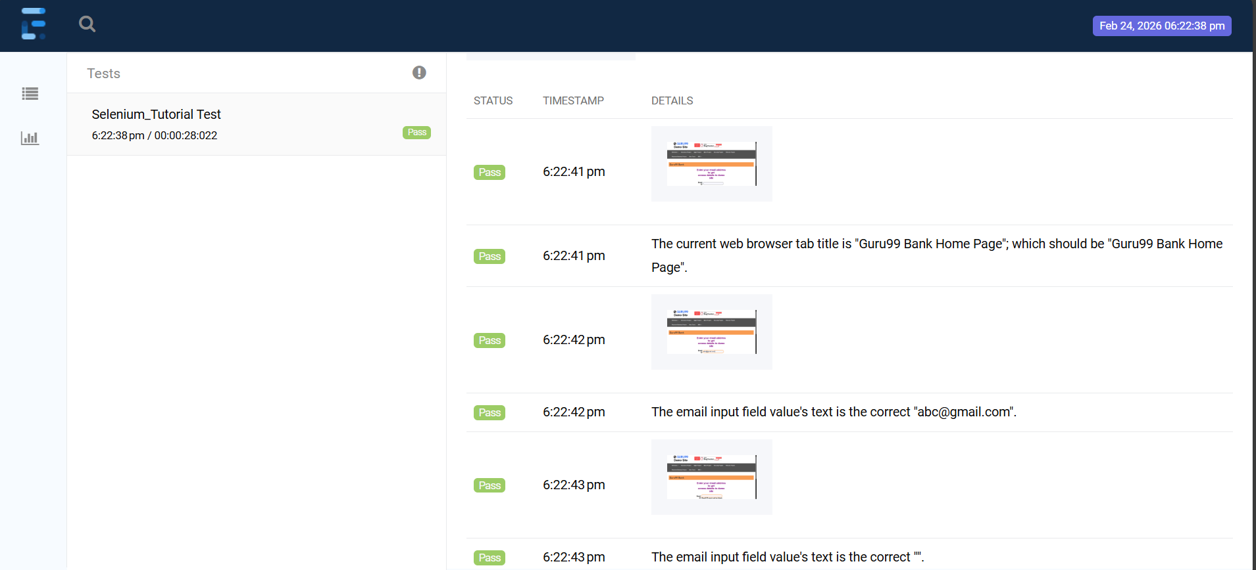

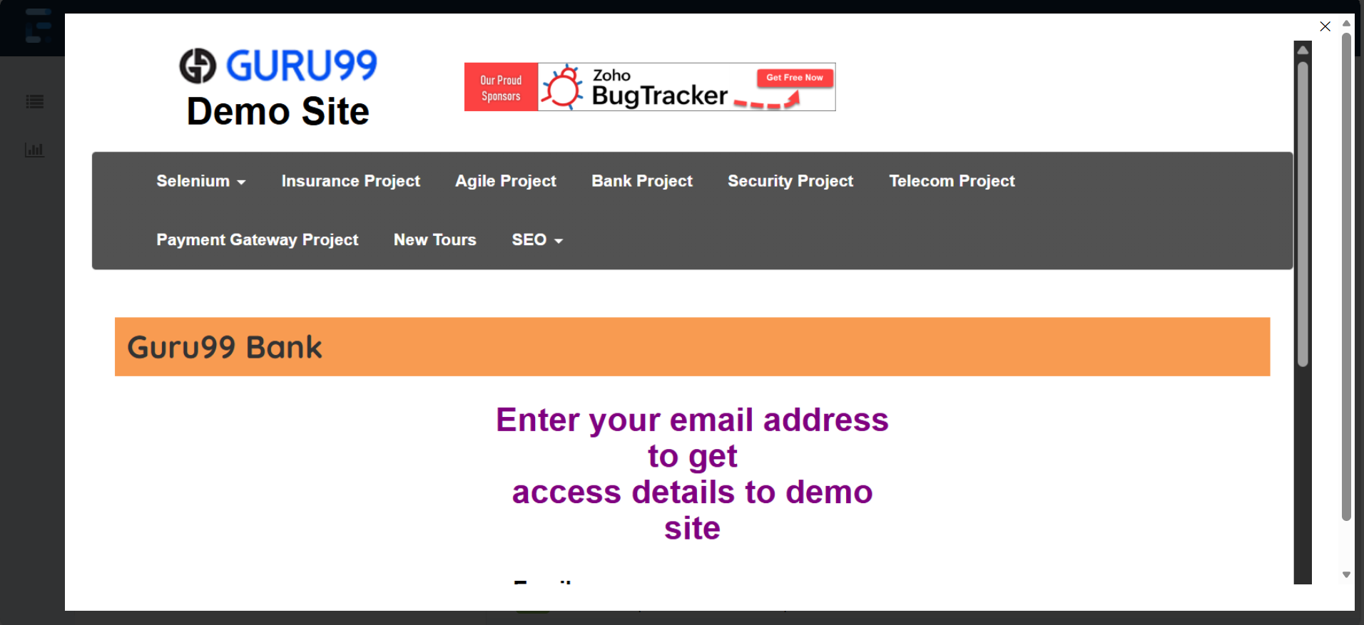
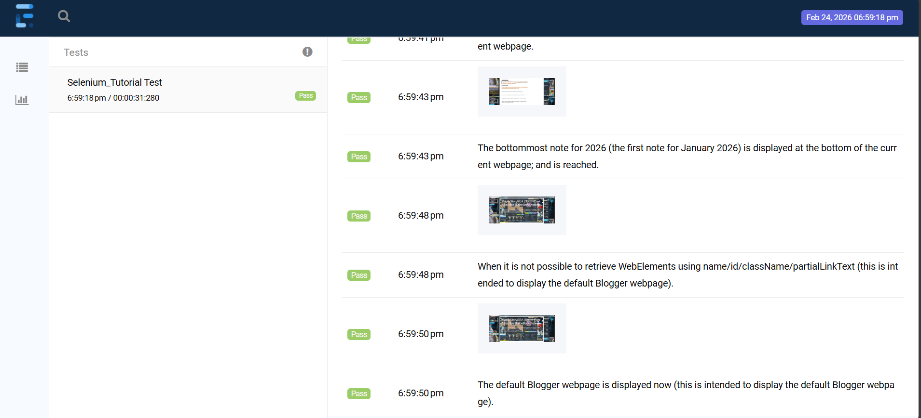

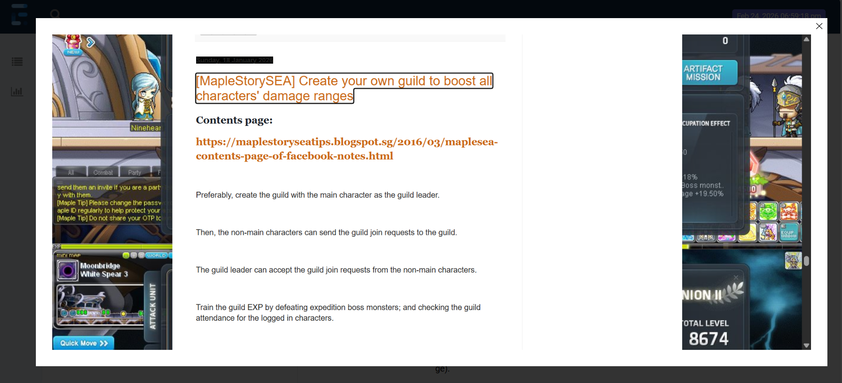

TestAndroidApps.java
package hellocucumber;

import com.aventstack.extentreports.ExtentReports;
import com.aventstack.extentreports.ExtentTest;
import com.aventstack.extentreports.reporter.ExtentSparkReporter;
import io.appium.java_client.android.AndroidDriver;
import io.cucumber.java.en.Given;
import io.cucumber.java.en.Then;
import io.cucumber.java.en.When;
import io.cucumber.junit.Cucumber;
import io.cucumber.junit.CucumberOptions;
import org.junit.runner.RunWith;
import org.openqa.selenium.remote.DesiredCapabilities;

import java.io.IOException;
import java.net.URL;
import java.time.LocalDateTime;

//TIP To <b>Run</b> code, press <shortcut actionId="Run"/> or
// click the <icon src="AllIcons.Actions.Execute"/> icon in the gutter.

//@CucumberContextConfiguration
@RunWith(Cucumber.class)
@CucumberOptions(
// features should start with "src/test/resources/features/xxxxxxxxxxx.feature",
features = "src/test/resources/features/Selenium_Android.feature",
// glue starts with "src/test/java/#package for the Test Java class with the Given;When;Then annotations#/",
glue={"src/test/java/hellocucumber/"},
// plugin = = {"pretty", "html:target/cucumber-reports"}
plugin = {"pretty", "html:target/cucumber-reports"}
)

public class TestAndroidApps {
// Test.java class should be within src > test

AndroidDriver driver1;
AndroidDriver driver2;

AndroidDriver driver3;

AndroidDriver driver4;
String websiteTitle = "";
String capturedScreenshotImageFilepathString = "";

String currentLocalDateTimeForExtentSparkReporter = currentLocalDateTimeWithDdMmYyFormat();

ExtentReports extentReport = new ExtentReports();
// should be target/Spark.html, not an actual filepath starting from C:\\
ExtentSparkReporter extentSparkReporter = new ExtentSparkReporter("target/Spark_" + currentLocalDateTimeForExtentSparkReporter + ".html");

ExtentTest extentTest = extentReport.createTest("Selenium_Android Test");

FirstAppObjects firstAppObjects;

SecondAppObjects secondAppObjects;

ThirdAppObjects thirdAppObjects;

public TestAndroidApps() throws IOException {
}

// Note that this method is not executed, if running the feature with the Given, When, Then lines
void testMethod() {
System.out.println("testing the IntelliJ IDEA - Help - Testing - Create Tests - Right-click to generate Test Method for JUnit5.");
}

@org.junit.Test
@org.junit.jupiter.api.Test
@org.testng.annotations.Test
@Given("I wish to learn how to automate a smartphone application which can be used for a real Android 15 device.")
public void testMethod1() throws IOException {
// this line only works without an error, in a public method, as it is a public void method
// the other three lines (originally above this fourth line) are public methods
extentReport.attachReporter(extentSparkReporter);

DesiredCapabilities desiredCapabilities = new DesiredCapabilities();
desiredCapabilities.setCapability("platformName", "Android");
desiredCapabilities.setCapability("appium:platformVersion", "16.0");
desiredCapabilities.setCapability("appium:app", "C:\\Users\\sohjnthn\\IdeaProjects\\Selenium_Tutorial\\app\\com.afwsamples.testdpc_9.0.12-9012_minAPI21(nodpi)_apkmirror.com.apk");
desiredCapabilities.setCapability("appium:automationName", "UiAutomator2");
driver1 = new AndroidDriver(new URL("http://127.0.0.1:4723/wd/hub"), desiredCapabilities);

firstAppObjects = new FirstAppObjects(driver1, extentTest, extentSparkReporter, extentReport);

}

@org.junit.Test
@org.junit.jupiter.api.Test
@org.testng.annotations.Test
@When("I provide the Given and When methods with a new object of the first non-main class.")
public void testMethod2() throws IOException {
firstAppObjects = new FirstAppObjects(driver1, extentTest, extentSparkReporter, extentReport);
}

@org.junit.Test
@org.junit.jupiter.api.Test
@org.testng.annotations.Test
@Then("I provide the Then method with the new objects of the second and third non-main classes.")
public void testMethod3() throws IOException {
DesiredCapabilities desiredCapabilities = new DesiredCapabilities();
desiredCapabilities.setCapability("platformName", "Android");
desiredCapabilities.setCapability("appium:platformVersion", "16.0");
desiredCapabilities.setCapability("appium:app", "C:\\Users\\sohjnthn\\IdeaProjects\\Selenium_Tutorial\\app\\ApiDemos-debug.apk");
desiredCapabilities.setCapability("appium:automationName", "UiAutomator2");
driver2 = new AndroidDriver(new URL("http://127.0.0.1:4723/wd/hub"), desiredCapabilities);

secondAppObjects = new SecondAppObjects(driver2, extentTest, extentSparkReporter, extentReport);

desiredCapabilities = new DesiredCapabilities();
desiredCapabilities.setCapability("platformName", "Android");
desiredCapabilities.setCapability("appium:platformVersion", "16.0");
desiredCapabilities.setCapability("appium:app", "C:\\Users\\sohjnthn\\IdeaProjects\\Selenium_Tutorial\\app\\com.microsoft.emmx.canary_138.0.3336.0-333600000_minAPI26(armeabi-v7a)(nodpi)_apkmirror.com.apk");
desiredCapabilities.setCapability("appium:automationName", "UiAutomator2");
driver3 = new AndroidDriver(new URL("http://127.0.0.1:4723/wd/hub"), desiredCapabilities);
thirdAppObjects = new ThirdAppObjects(driver3, extentTest, extentSparkReporter, extentReport);
}

public static String currentLocalDateTimeWithDdMmYyFormat() throws IOException {
char dayFirstDigitChar = '0';
char daySecondDigitChar = '0';
char monthFirstDigitChar = '0';
char monthSecondDigitChar = '0';
char yearFirstDigitChar = '0';
char yearSecondDigitChar = '0';
char yearThirdDigitChar = '0';
char yearFourthDigitChar = '0';
char hourFirstDigitChar = '0';
char hourSecondDigitChar = '0';
char minuteFirstDigitChar = '0';
char minuteSecondDigitChar = '0';
char secondFirstDigitChar = '0';
char secondSecondDigitChar = '0';
char subsecondFirstDigitChar = '0';
char subsecondSecondDigitChar = '0';
char subsecondThirdDigitChar = '0';
char subsecondFourthDigitChar = '0';
char subsecondFifthDigitChar = '0';
char subsecondSixthDigitChar = '0';
// Issue - Missing these three digits
char subsecondSeventhDigitChar = '0';
char subsecondEighthDigitChar = '0';
char subsecondNinthDigitChar = '0';

// How to take Selenium screenshot image
LocalDateTime localDateTime = LocalDateTime.now();

String initialLocalDateTimeString = localDateTime.toString();

String initialLocalDateTimeStringDaySubstring = initialLocalDateTimeString.substring(8, 10);

String initialLocalDateTimeStringDashMonthDashSubstring = initialLocalDateTimeString.substring(4, 8);

String initialLocalDateTimeStringYearSubstring = initialLocalDateTimeString.substring(0, 4);

String initialLocalDateTimeStringTimeSubString = initialLocalDateTimeString.substring(10);

// Not providing as (10, 29) which caused an issue, as found out that intialLocalDateTimeString can be have 26, 27, 28, or 29 characters
String finalLocalDateTimeString = initialLocalDateTimeStringDaySubstring + initialLocalDateTimeStringDashMonthDashSubstring + initialLocalDateTimeStringYearSubstring + initialLocalDateTimeStringTimeSubString;

if(finalLocalDateTimeString.length()>=1) {
// index 0 character; 1st character
dayFirstDigitChar = finalLocalDateTimeString.charAt(0);
}

if(finalLocalDateTimeString.length()>=2) {
// index 1 character; 2nd character
daySecondDigitChar = finalLocalDateTimeString.charAt(1);
}

if(finalLocalDateTimeString.length()>=4) {
// index 3 character; 4th character
monthFirstDigitChar = finalLocalDateTimeString.charAt(3);
}

if(finalLocalDateTimeString.length()>=5) {
// index 4 character; 5th character
monthSecondDigitChar = finalLocalDateTimeString.charAt(4);
}

if(finalLocalDateTimeString.length()>=7) {
// index 6 character; 7th character
yearFirstDigitChar = finalLocalDateTimeString.charAt(6);
}

if(finalLocalDateTimeString.length()>=8) {
// index 7 character; 8th character
yearSecondDigitChar = finalLocalDateTimeString.charAt(7);
}

if(finalLocalDateTimeString.length()>=9) {
// index 8 character; 9th character
yearThirdDigitChar = finalLocalDateTimeString.charAt(8);
}

if(finalLocalDateTimeString.length()>=10) {
// index 9 character; 10th character
yearFourthDigitChar = finalLocalDateTimeString.charAt(9);
}

if(finalLocalDateTimeString.length()>=12) {
// index 11 character; 12th character
hourFirstDigitChar = finalLocalDateTimeString.charAt(11);
}

if(finalLocalDateTimeString.length()>=13){
// index 12 character; 13th character
hourSecondDigitChar = finalLocalDateTimeString.charAt(12);
}

if(finalLocalDateTimeString.length()>=15) {
// index 14 character; 15th character
minuteFirstDigitChar = finalLocalDateTimeString.charAt(14);
}

if(finalLocalDateTimeString.length()>=16) {
// index 15 character; 16th character
minuteSecondDigitChar = finalLocalDateTimeString.charAt(15);
}

if(finalLocalDateTimeString.length()>=18) {
// index 17 character; 18th character
secondFirstDigitChar = finalLocalDateTimeString.charAt(17);
}

if(finalLocalDateTimeString.length()>=19) {
// index 18 character; 19th character
secondSecondDigitChar = finalLocalDateTimeString.charAt(18);
}

if(finalLocalDateTimeString.length()>=21) {
// index 20 character; 21th character
subsecondFirstDigitChar = finalLocalDateTimeString.charAt(20);
}

if(finalLocalDateTimeString.length()>=22) {
// index 21 character; 22nd character
subsecondSecondDigitChar = finalLocalDateTimeString.charAt(21);
}

if(finalLocalDateTimeString.length()>=23) {
// index 22 character; 23rd character
subsecondThirdDigitChar = finalLocalDateTimeString.charAt(22);
}

if(finalLocalDateTimeString.length()>=24) {
// index 23 character; 24th character
subsecondFourthDigitChar = finalLocalDateTimeString.charAt(23);
}

if(finalLocalDateTimeString.length()>=25) {
// index 24 character; 25th character
subsecondFifthDigitChar = finalLocalDateTimeString.charAt(24);
}

if(finalLocalDateTimeString.length()>=26) {
// index 25 character; 26th character
subsecondSixthDigitChar = finalLocalDateTimeString.charAt(25);
}

if(finalLocalDateTimeString.length()>=27) {
// index 26 character; 27th character
subsecondSeventhDigitChar = finalLocalDateTimeString.charAt(26);
}

if(finalLocalDateTimeString.length()>=28) {
// index 27 character; 28th character
subsecondEighthDigitChar = finalLocalDateTimeString.charAt(27);
}

if(finalLocalDateTimeString.length()>=29) {
// index 28 character; 29th character
subsecondNinthDigitChar = finalLocalDateTimeString.charAt(28);
}

// There seems to be an error for which the two digits for day are incorrect, so localDateTime.getDayOfmonth is used(), instead of dayFirstDigitChar and daySecondDigitChar
return localDateTime.getDayOfMonth() + "-" + monthFirstDigitChar + monthSecondDigitChar + "-" + yearFirstDigitChar + yearSecondDigitChar + yearThirdDigitChar + yearFourthDigitChar + "T" + hourFirstDigitChar + hourSecondDigitChar + minuteFirstDigitChar + minuteSecondDigitChar + secondFirstDigitChar + secondSecondDigitChar + "." + subsecondFirstDigitChar + subsecondSecondDigitChar + subsecondThirdDigitChar + subsecondFourthDigitChar + subsecondFifthDigitChar + subsecondSixthDigitChar + subsecondSeventhDigitChar + subsecondEighthDigitChar + subsecondNinthDigitChar;
}
}

FirstAppObjects.java
package hellocucumber;

import com.aventstack.extentreports.ExtentReports;
import com.aventstack.extentreports.ExtentTest;
import com.aventstack.extentreports.MediaEntityBuilder;
import com.aventstack.extentreports.Status;
import com.aventstack.extentreports.reporter.ExtentSparkReporter;
import io.appium.java_client.android.AndroidDriver;
import io.appium.java_client.pagefactory.AndroidFindBy;
import org.openqa.selenium.*;
import org.openqa.selenium.io.FileHandler;

import java.io.File;
import java.io.IOException;
import java.time.LocalDateTime;

public class FirstAppObjects {

// First App
@AndroidFindBy(xpath = "//android.widget.TextView[@text=\"Policy management\"]")
WebElement policyManagementText;

AndroidDriver driver;

String capturedScreenshotImageFilepathString = "";

public FirstAppObjects(AndroidDriver driver, ExtentTest extentTest, ExtentSparkReporter extentSparkReporter, ExtentReports extentReport) throws IOException {

policyManagementText = driver.findElement(By.xpath("//android.widget.TextView[@text=\"Policy management\"]"));

if(policyManagementText.isDisplayed()){
capturedScreenshotImageFilepathString = takeScreenshot(driver);
extentTest.addScreenCaptureFromPath(capturedScreenshotImageFilepathString).pass(MediaEntityBuilder.createScreenCaptureFromPath(capturedScreenshotImageFilepathString).build()).log(Status.PASS, "Able to find \"Policy Management\".");
System.out.println("Pass");
} else {
capturedScreenshotImageFilepathString = takeScreenshot(driver);
extentTest.addScreenCaptureFromPath(capturedScreenshotImageFilepathString).pass(MediaEntityBuilder.createScreenCaptureFromPath(capturedScreenshotImageFilepathString).build()).log(Status.FAIL, "Unable to find \"Policy Management\".");
System.out.println("Fail");
}
}

public static String takeScreenshot(WebDriver driver) throws IOException {
char dayFirstDigitChar = '0';
char daySecondDigitChar = '0';
char monthFirstDigitChar = '0';
char monthSecondDigitChar = '0';
char yearFirstDigitChar = '0';
char yearSecondDigitChar = '0';
char yearThirdDigitChar = '0';
char yearFourthDigitChar = '0';
char hourFirstDigitChar = '0';
char hourSecondDigitChar = '0';
char minuteFirstDigitChar = '0';
char minuteSecondDigitChar = '0';
char secondFirstDigitChar = '0';
char secondSecondDigitChar = '0';
char subsecondFirstDigitChar = '0';
char subsecondSecondDigitChar = '0';
char subsecondThirdDigitChar = '0';
char subsecondFourthDigitChar = '0';
char subsecondFifthDigitChar = '0';
char subsecondSixthDigitChar = '0';
// Issue - Missing these three digits
char subsecondSeventhDigitChar = '0';
char subsecondEighthDigitChar = '0';
char subsecondNinthDigitChar = '0';

LocalDateTime localDateTime = LocalDateTime.now();

String initialLocalDateTimeString = localDateTime.toString();

String initialLocalDateTimeStringDaySubstring = initialLocalDateTimeString.substring(8, 10);

String initialLocalDateTimeStringDashMonthDashSubstring = initialLocalDateTimeString.substring(4, 8);

String initialLocalDateTimeStringYearSubstring = initialLocalDateTimeString.substring(0, 4);

// Not providing as (10, 29) which caused an issue, as found out that intialLocalDateTimeString can be have 26, 27, 28, or 29 characters
String initialLocalDateTimeStringTimeSubString = initialLocalDateTimeString.substring(10);

String finalLocalDateTimeString = initialLocalDateTimeStringDaySubstring + initialLocalDateTimeStringDashMonthDashSubstring + initialLocalDateTimeStringYearSubstring + initialLocalDateTimeStringTimeSubString;

if(finalLocalDateTimeString.length()>=1) {
dayFirstDigitChar = finalLocalDateTimeString.charAt(0);
}

if(finalLocalDateTimeString.length()>=2) {
daySecondDigitChar = finalLocalDateTimeString.charAt(1);
}

if(finalLocalDateTimeString.length()>=4) {
monthFirstDigitChar = finalLocalDateTimeString.charAt(3);
}

if(finalLocalDateTimeString.length()>=5) {
monthSecondDigitChar = finalLocalDateTimeString.charAt(4);
}

if(finalLocalDateTimeString.length()>=7) {
yearFirstDigitChar = finalLocalDateTimeString.charAt(6);
}

if(finalLocalDateTimeString.length()>=8) {
yearSecondDigitChar = finalLocalDateTimeString.charAt(7);
}

if(finalLocalDateTimeString.length()>=9) {
yearThirdDigitChar = finalLocalDateTimeString.charAt(8);
}

if(finalLocalDateTimeString.length()>=10) {
yearFourthDigitChar = finalLocalDateTimeString.charAt(9);
}

if(finalLocalDateTimeString.length()>=12) {
hourFirstDigitChar = finalLocalDateTimeString.charAt(11);
}

if(finalLocalDateTimeString.length()>=13){
hourSecondDigitChar = finalLocalDateTimeString.charAt(12);
}

if(finalLocalDateTimeString.length()>=15) {
minuteFirstDigitChar = finalLocalDateTimeString.charAt(14);
}

if(finalLocalDateTimeString.length()>=16) {
minuteSecondDigitChar = finalLocalDateTimeString.charAt(15);
}

if(finalLocalDateTimeString.length()>=18) {
secondFirstDigitChar = finalLocalDateTimeString.charAt(17);
}

if(finalLocalDateTimeString.length()>=19) {
secondSecondDigitChar = finalLocalDateTimeString.charAt(18);
}

if(finalLocalDateTimeString.length()>=21) {
subsecondFirstDigitChar = finalLocalDateTimeString.charAt(20);
}

if(finalLocalDateTimeString.length()>=22) {
subsecondSecondDigitChar = finalLocalDateTimeString.charAt(21);
}

if(finalLocalDateTimeString.length()>=23) {
subsecondThirdDigitChar = finalLocalDateTimeString.charAt(22);
}

if(finalLocalDateTimeString.length()>=24) {
subsecondFourthDigitChar = finalLocalDateTimeString.charAt(23);
}

if(finalLocalDateTimeString.length()>=25) {
subsecondFifthDigitChar = finalLocalDateTimeString.charAt(24);
}

if(finalLocalDateTimeString.length()>=26) {
subsecondSixthDigitChar = finalLocalDateTimeString.charAt(25);
}

if(finalLocalDateTimeString.length()>=27) {
subsecondSeventhDigitChar = finalLocalDateTimeString.charAt(26);
}

if(finalLocalDateTimeString.length()>=28) {
subsecondEighthDigitChar = finalLocalDateTimeString.charAt(27);
}

if(finalLocalDateTimeString.length()>=29) {
subsecondNinthDigitChar = finalLocalDateTimeString.charAt(28);
}

TakesScreenshot screenshot = ((TakesScreenshot) driver);
File sourceFile = screenshot.getScreenshotAs(OutputType.FILE);
File destinationFile = new File("C:\\Users\\sohjnthn\\IdeaProjects\\Selenium_Tutorial\\Selenium_Screenshot_Images\\" + dayFirstDigitChar + daySecondDigitChar + "-" + monthFirstDigitChar + monthSecondDigitChar + "-" + yearFirstDigitChar + yearSecondDigitChar + yearThirdDigitChar + yearFourthDigitChar + "T" + hourFirstDigitChar + hourSecondDigitChar + minuteFirstDigitChar + minuteSecondDigitChar + secondFirstDigitChar + secondSecondDigitChar + "." + subsecondFirstDigitChar + subsecondSecondDigitChar + subsecondThirdDigitChar + subsecondFourthDigitChar + subsecondFifthDigitChar + subsecondSixthDigitChar + subsecondSeventhDigitChar + subsecondEighthDigitChar + subsecondNinthDigitChar + "_screenshot.png");
FileHandler.copy(sourceFile, destinationFile);

return "C:\\Users\\sohjnthn\\IdeaProjects\\Selenium_Tutorial\\Selenium_Screenshot_Images\\" + dayFirstDigitChar + daySecondDigitChar + "-" + monthFirstDigitChar + monthSecondDigitChar + "-" + yearFirstDigitChar + yearSecondDigitChar + yearThirdDigitChar + yearFourthDigitChar + "T" + hourFirstDigitChar + hourSecondDigitChar + minuteFirstDigitChar + minuteSecondDigitChar + secondFirstDigitChar + secondSecondDigitChar + "." + subsecondFirstDigitChar + subsecondSecondDigitChar + subsecondThirdDigitChar + subsecondFourthDigitChar + subsecondFifthDigitChar + subsecondSixthDigitChar + subsecondSeventhDigitChar + subsecondEighthDigitChar + subsecondNinthDigitChar + "_screenshot.png";
}
}

SecondAppObjects.java
package hellocucumber;

import com.aventstack.extentreports.ExtentReports;
import com.aventstack.extentreports.ExtentTest;
import com.aventstack.extentreports.MediaEntityBuilder;
import com.aventstack.extentreports.Status;
import com.aventstack.extentreports.reporter.ExtentSparkReporter;
import io.appium.java_client.android.AndroidDriver;
import io.appium.java_client.pagefactory.AndroidFindBy;
import org.openqa.selenium.*;
import org.openqa.selenium.io.FileHandler;

import java.io.File;
import java.io.IOException;
import java.time.LocalDateTime;

public class SecondAppObjects {

// Second App
@AndroidFindBy(xpath = "//android.widget.TextView[@content-desc=\"App\"]")
WebElement appTab;

@AndroidFindBy(xpath = "//android.widget.TextView[@content-desc=\"Search\"]")
WebElement searchTab;

@AndroidFindBy(xpath = "//android.widget.TextView[@content-desc=\"Invoke Search\"]")
WebElement invokeSearchTab;

@AndroidFindBy(xpath = "//android.widget.EditText[@resource-id=\"io.appium.android.apis:id/txt_query_prefill\"]")
WebElement prefillQueryTextField;

String capturedScreenshotImageFilepathString = "";

public SecondAppObjects(AndroidDriver driver, ExtentTest extentTest, ExtentSparkReporter extentSparkReporter, ExtentReports extentReport) throws IOException {
WebElement appTab = driver.findElement(By.xpath("//android.widget.TextView[@content-desc=\"App\"]"));

if (appTab.isDisplayed()) {
capturedScreenshotImageFilepathString = takeScreenshot(driver);
extentTest.addScreenCaptureFromPath(capturedScreenshotImageFilepathString).pass(MediaEntityBuilder.createScreenCaptureFromPath(capturedScreenshotImageFilepathString).build()).log(Status.PASS, "App tab is displayed.");
} else {
capturedScreenshotImageFilepathString = takeScreenshot(driver);
extentTest.addScreenCaptureFromPath(capturedScreenshotImageFilepathString).pass(MediaEntityBuilder.createScreenCaptureFromPath(capturedScreenshotImageFilepathString).build()).log(Status.FAIL, "App tab is not displayed.");
}
appTab.click();

WebElement searchTab = driver.findElement(By.xpath("//android.widget.TextView[@content-desc=\"Search\"]"));
if (searchTab.isDisplayed()) {
capturedScreenshotImageFilepathString = takeScreenshot(driver);
extentTest.addScreenCaptureFromPath(capturedScreenshotImageFilepathString).pass(MediaEntityBuilder.createScreenCaptureFromPath(capturedScreenshotImageFilepathString).build()).log(Status.PASS, "Search tab is displayed.");
} else {
capturedScreenshotImageFilepathString = takeScreenshot(driver);
extentTest.addScreenCaptureFromPath(capturedScreenshotImageFilepathString).pass(MediaEntityBuilder.createScreenCaptureFromPath(capturedScreenshotImageFilepathString).build()).log(Status.FAIL, "Search tab is not displayed.");
}
searchTab.click();

WebElement invokeSearchTab = driver.findElement(By.xpath("//android.widget.TextView[@content-desc=\"Invoke Search\"]"));
if (invokeSearchTab.isDisplayed()) {
capturedScreenshotImageFilepathString = takeScreenshot(driver);
extentTest.addScreenCaptureFromPath(capturedScreenshotImageFilepathString).pass(MediaEntityBuilder.createScreenCaptureFromPath(capturedScreenshotImageFilepathString).build()).log(Status.PASS, "Invoke Search tab is displayed.");
} else {
capturedScreenshotImageFilepathString = takeScreenshot(driver);
extentTest.addScreenCaptureFromPath(capturedScreenshotImageFilepathString).pass(MediaEntityBuilder.createScreenCaptureFromPath(capturedScreenshotImageFilepathString).build()).log(Status.FAIL, "Invoke Search tab is not displayed.");
}
invokeSearchTab.click();

WebElement prefillQueryTextField = driver.findElement(By.xpath("//android.widget.EditText[@resource-id=\"io.appium.android.apis:id/txt_query_prefill\"]"));
if (prefillQueryTextField.isDisplayed()) {
capturedScreenshotImageFilepathString = takeScreenshot(driver);
extentTest.addScreenCaptureFromPath(capturedScreenshotImageFilepathString).pass(MediaEntityBuilder.createScreenCaptureFromPath(capturedScreenshotImageFilepathString).build()).log(Status.PASS, "Before entering the text - Pass.");
System.out.println("Pass");
} else {
capturedScreenshotImageFilepathString = takeScreenshot(driver);
extentTest.addScreenCaptureFromPath(capturedScreenshotImageFilepathString).pass(MediaEntityBuilder.createScreenCaptureFromPath(capturedScreenshotImageFilepathString).build()).log(Status.FAIL, "Before entering the text - Fail.");
System.out.println("Fail");
}

prefillQueryTextField.sendKeys("Test the text.");

if (prefillQueryTextField.isDisplayed()) {
capturedScreenshotImageFilepathString = takeScreenshot(driver);
extentTest.addScreenCaptureFromPath(capturedScreenshotImageFilepathString).pass(MediaEntityBuilder.createScreenCaptureFromPath(capturedScreenshotImageFilepathString).build()).log(Status.PASS, "Able to enter the text \"Test the text.\".");
System.out.println("Pass");
} else {
capturedScreenshotImageFilepathString = takeScreenshot(driver);
extentTest.addScreenCaptureFromPath(capturedScreenshotImageFilepathString).pass(MediaEntityBuilder.createScreenCaptureFromPath(capturedScreenshotImageFilepathString).build()).log(Status.FAIL, "Unable to enter the text \"Test the text.\".");
System.out.println("Fail");
}
}

public static String takeScreenshot(WebDriver driver) throws IOException {
char dayFirstDigitChar = '0';
char daySecondDigitChar = '0';
char monthFirstDigitChar = '0';
char monthSecondDigitChar = '0';
char yearFirstDigitChar = '0';
char yearSecondDigitChar = '0';
char yearThirdDigitChar = '0';
char yearFourthDigitChar = '0';
char hourFirstDigitChar = '0';
char hourSecondDigitChar = '0';
char minuteFirstDigitChar = '0';
char minuteSecondDigitChar = '0';
char secondFirstDigitChar = '0';
char secondSecondDigitChar = '0';
char subsecondFirstDigitChar = '0';
char subsecondSecondDigitChar = '0';
char subsecondThirdDigitChar = '0';
char subsecondFourthDigitChar = '0';
char subsecondFifthDigitChar = '0';
char subsecondSixthDigitChar = '0';
// Issue - Missing these three digits
char subsecondSeventhDigitChar = '0';
char subsecondEighthDigitChar = '0';
char subsecondNinthDigitChar = '0';

LocalDateTime localDateTime = LocalDateTime.now();

String initialLocalDateTimeString = localDateTime.toString();

String initialLocalDateTimeStringDaySubstring = initialLocalDateTimeString.substring(8, 10);

String initialLocalDateTimeStringDashMonthDashSubstring = initialLocalDateTimeString.substring(4, 8);

String initialLocalDateTimeStringYearSubstring = initialLocalDateTimeString.substring(0, 4);

// Not providing as (10, 29) which caused an issue, as found out that intialLocalDateTimeString can be have 26, 27, 28, or 29 characters
String initialLocalDateTimeStringTimeSubString = initialLocalDateTimeString.substring(10);

String finalLocalDateTimeString = initialLocalDateTimeStringDaySubstring + initialLocalDateTimeStringDashMonthDashSubstring + initialLocalDateTimeStringYearSubstring + initialLocalDateTimeStringTimeSubString;

if(finalLocalDateTimeString.length()>=1) {
dayFirstDigitChar = finalLocalDateTimeString.charAt(0);
}

if(finalLocalDateTimeString.length()>=2) {
daySecondDigitChar = finalLocalDateTimeString.charAt(1);
}

if(finalLocalDateTimeString.length()>=4) {
monthFirstDigitChar = finalLocalDateTimeString.charAt(3);
}

if(finalLocalDateTimeString.length()>=5) {
monthSecondDigitChar = finalLocalDateTimeString.charAt(4);
}

if(finalLocalDateTimeString.length()>=7) {
yearFirstDigitChar = finalLocalDateTimeString.charAt(6);
}

if(finalLocalDateTimeString.length()>=8) {
yearSecondDigitChar = finalLocalDateTimeString.charAt(7);
}

if(finalLocalDateTimeString.length()>=9) {
yearThirdDigitChar = finalLocalDateTimeString.charAt(8);
}

if(finalLocalDateTimeString.length()>=10) {
yearFourthDigitChar = finalLocalDateTimeString.charAt(9);
}

if(finalLocalDateTimeString.length()>=12) {
hourFirstDigitChar = finalLocalDateTimeString.charAt(11);
}

if(finalLocalDateTimeString.length()>=13){
hourSecondDigitChar = finalLocalDateTimeString.charAt(12);
}

if(finalLocalDateTimeString.length()>=15) {
minuteFirstDigitChar = finalLocalDateTimeString.charAt(14);
}

if(finalLocalDateTimeString.length()>=16) {
minuteSecondDigitChar = finalLocalDateTimeString.charAt(15);
}

if(finalLocalDateTimeString.length()>=18) {
secondFirstDigitChar = finalLocalDateTimeString.charAt(17);
}

if(finalLocalDateTimeString.length()>=19) {
secondSecondDigitChar = finalLocalDateTimeString.charAt(18);
}

if(finalLocalDateTimeString.length()>=21) {
subsecondFirstDigitChar = finalLocalDateTimeString.charAt(20);
}

if(finalLocalDateTimeString.length()>=22) {
subsecondSecondDigitChar = finalLocalDateTimeString.charAt(21);
}

if(finalLocalDateTimeString.length()>=23) {
subsecondThirdDigitChar = finalLocalDateTimeString.charAt(22);
}

if(finalLocalDateTimeString.length()>=24) {
subsecondFourthDigitChar = finalLocalDateTimeString.charAt(23);
}

if(finalLocalDateTimeString.length()>=25) {
subsecondFifthDigitChar = finalLocalDateTimeString.charAt(24);
}

if(finalLocalDateTimeString.length()>=26) {
subsecondSixthDigitChar = finalLocalDateTimeString.charAt(25);
}

if(finalLocalDateTimeString.length()>=27) {
subsecondSeventhDigitChar = finalLocalDateTimeString.charAt(26);
}

if(finalLocalDateTimeString.length()>=28) {
subsecondEighthDigitChar = finalLocalDateTimeString.charAt(27);
}

if(finalLocalDateTimeString.length()>=29) {
subsecondNinthDigitChar = finalLocalDateTimeString.charAt(28);
}

TakesScreenshot screenshot = ((TakesScreenshot) driver);
File sourceFile = screenshot.getScreenshotAs(OutputType.FILE);
File destinationFile = new File("C:\\Users\\sohjnthn\\IdeaProjects\\Selenium_Tutorial\\Selenium_Screenshot_Images\\" + dayFirstDigitChar + daySecondDigitChar + "-" + monthFirstDigitChar + monthSecondDigitChar + "-" + yearFirstDigitChar + yearSecondDigitChar + yearThirdDigitChar + yearFourthDigitChar + "T" + hourFirstDigitChar + hourSecondDigitChar + minuteFirstDigitChar + minuteSecondDigitChar + secondFirstDigitChar + secondSecondDigitChar + "." + subsecondFirstDigitChar + subsecondSecondDigitChar + subsecondThirdDigitChar + subsecondFourthDigitChar + subsecondFifthDigitChar + subsecondSixthDigitChar + subsecondSeventhDigitChar + subsecondEighthDigitChar + subsecondNinthDigitChar + "_screenshot.png");
FileHandler.copy(sourceFile, destinationFile);

return "C:\\Users\\sohjnthn\\IdeaProjects\\Selenium_Tutorial\\Selenium_Screenshot_Images\\" + dayFirstDigitChar + daySecondDigitChar + "-" + monthFirstDigitChar + monthSecondDigitChar + "-" + yearFirstDigitChar + yearSecondDigitChar + yearThirdDigitChar + yearFourthDigitChar + "T" + hourFirstDigitChar + hourSecondDigitChar + minuteFirstDigitChar + minuteSecondDigitChar + secondFirstDigitChar + secondSecondDigitChar + "." + subsecondFirstDigitChar + subsecondSecondDigitChar + subsecondThirdDigitChar + subsecondFourthDigitChar + subsecondFifthDigitChar + subsecondSixthDigitChar + subsecondSeventhDigitChar + subsecondEighthDigitChar + subsecondNinthDigitChar + "_screenshot.png";
}
}

ThirdAppObjects.java
package hellocucumber;

import io.appium.java_client.remote.SupportsContextSwitching;
import com.aventstack.extentreports.ExtentReports;
import com.aventstack.extentreports.ExtentTest;
import com.aventstack.extentreports.MediaEntityBuilder;
import com.aventstack.extentreports.Status;
import com.aventstack.extentreports.reporter.ExtentSparkReporter;
import io.appium.java_client.android.AndroidDriver;
import io.appium.java_client.pagefactory.AndroidFindBy;
import org.openqa.selenium.*;
import org.openqa.selenium.io.FileHandler;

import java.io.File;
import java.io.IOException;
import java.time.LocalDateTime;
import java.util.Objects;
import java.util.Set;

public class ThirdAppObjects {

// Third App
@AndroidFindBy(xpath = "//android.widget.EditText[@resource-id=\"com.microsoft.emmx.canary:id/url_bar\"]")
WebElement edgeBrowserDefaultWebpageSearchBar;

@AndroidFindBy(xpath = "//android.widget.TextView[@resource-id=\"com.microsoft.emmx.canary:id/line_1\"]\n")
WebElement requiredSearchOption;

@AndroidFindBy(xpath = "//android.widget.FrameLayout[@content-desc=\"Web View\"]")
WebElement searchResultsWebpageView;

String capturedScreenshotImageFilepathString = "";

public ThirdAppObjects(AndroidDriver driver, ExtentTest extentTest, ExtentSparkReporter extentSparkReporter, ExtentReports extentReport) throws IOException {
String oneString = "1";
// Due to the need to manually click on multiple sign in confirmation buttons
for(int i=0; i<99999; i++) {
System.out.println("The app requires time to load.");
}

edgeBrowserDefaultWebpageSearchBar = driver.findElement(By.xpath("//android.widget.EditText[@resource-id=\"com.microsoft.emmx.canary:id/url_bar\"]"));

if(edgeBrowserDefaultWebpageSearchBar.isDisplayed()){
capturedScreenshotImageFilepathString = takeScreenshot(driver);
extentTest.addScreenCaptureFromPath(capturedScreenshotImageFilepathString).pass(MediaEntityBuilder.createScreenCaptureFromPath(capturedScreenshotImageFilepathString).build()).log(Status.PASS, "The Edge Browser default webpage search bar is displayed.");
System.out.println("Pass");
} else {
capturedScreenshotImageFilepathString = takeScreenshot(driver);
extentTest.addScreenCaptureFromPath(capturedScreenshotImageFilepathString).pass(MediaEntityBuilder.createScreenCaptureFromPath(capturedScreenshotImageFilepathString).build()).log(Status.FAIL, "he Edge Browser default webpage search bar is not displayed.");
System.out.println("Fail");
}

edgeBrowserDefaultWebpageSearchBar.click();

if(edgeBrowserDefaultWebpageSearchBar.isDisplayed()){
capturedScreenshotImageFilepathString = takeScreenshot(driver);
extentTest.addScreenCaptureFromPath(capturedScreenshotImageFilepathString).pass(MediaEntityBuilder.createScreenCaptureFromPath(capturedScreenshotImageFilepathString).build()).log(Status.PASS, "The Edge Browser default webpage search bar is displayed.");
System.out.println("Pass");
} else {
capturedScreenshotImageFilepathString = takeScreenshot(driver);
extentTest.addScreenCaptureFromPath(capturedScreenshotImageFilepathString).pass(MediaEntityBuilder.createScreenCaptureFromPath(capturedScreenshotImageFilepathString).build()).log(Status.FAIL, "he Edge Browser default webpage search bar is not displayed.");
System.out.println("Fail");
}

edgeBrowserDefaultWebpageSearchBar.sendKeys("MapleStorySEA (South-East Asia) tips [Facebook notes]");

if(edgeBrowserDefaultWebpageSearchBar.isDisplayed()){
capturedScreenshotImageFilepathString = takeScreenshot(driver);
extentTest.addScreenCaptureFromPath(capturedScreenshotImageFilepathString).pass(MediaEntityBuilder.createScreenCaptureFromPath(capturedScreenshotImageFilepathString).build()).log(Status.PASS, "The Edge Browser default webpage search bar contains the entered search term.");
System.out.println("Pass");
} else {
capturedScreenshotImageFilepathString = takeScreenshot(driver);
extentTest.addScreenCaptureFromPath(capturedScreenshotImageFilepathString).pass(MediaEntityBuilder.createScreenCaptureFromPath(capturedScreenshotImageFilepathString).build()).log(Status.FAIL, "The Edge Browser default webpage search bar does not contain the entered search term.");
System.out.println("Fail");
}

requiredSearchOption = driver.findElement(By.xpath("//android.widget.TextView[@resource-id=\"com.microsoft.emmx.canary:id/line_1\"]\n"));

if(requiredSearchOption.isDisplayed()){
capturedScreenshotImageFilepathString = takeScreenshot(driver);
extentTest.addScreenCaptureFromPath(capturedScreenshotImageFilepathString).pass(MediaEntityBuilder.createScreenCaptureFromPath(capturedScreenshotImageFilepathString).build()).log(Status.PASS, "The Edge Browser default webpage search bar contains the entered search term.");
System.out.println("Pass");
} else {
capturedScreenshotImageFilepathString = takeScreenshot(driver);
extentTest.addScreenCaptureFromPath(capturedScreenshotImageFilepathString).pass(MediaEntityBuilder.createScreenCaptureFromPath(capturedScreenshotImageFilepathString).build()).log(Status.FAIL, "The Edge Browser default webpage search bar does not contain the entered search term.");
System.out.println("Fail");
}

requiredSearchOption.click();

// There may be a very short delay
for (int i=0; i<2; i++) {
System.out.println("The required search results webpage is still loading.");
}

searchResultsWebpageView = driver.findElement(By.xpath("//android.widget.FrameLayout[@content-desc=\"Web View\"]"));

// The following line cannot be used as the WebElement is not found
// WebElement requiredSearchResultLink = driver.findElement(By.partialLinkText("Featured | [MapleStorySEA] Unfunded Tips"));

if(searchResultsWebpageView.isDisplayed()){
capturedScreenshotImageFilepathString = takeScreenshot(driver);
extentTest.addScreenCaptureFromPath(capturedScreenshotImageFilepathString).pass(MediaEntityBuilder.createScreenCaptureFromPath(capturedScreenshotImageFilepathString).build()).log(Status.PASS, "The required search results webpage is reached.");
System.out.println("Pass");
} else {
capturedScreenshotImageFilepathString = takeScreenshot(driver);
extentTest.addScreenCaptureFromPath(capturedScreenshotImageFilepathString).pass(MediaEntityBuilder.createScreenCaptureFromPath(capturedScreenshotImageFilepathString).build()).log(Status.FAIL, "The required search results webpage is not reached.");
System.out.println("Fail");
}

// For "//android.widget.FrameLayout[@content-desc=\"Web View\"]"
// sending the key KEYS.TAB would cause the test to fail
// We can only click on it
// And we cannot select any specific individual part as an element

// Noting that what was clicked on is not the correct search result for the default Featured tab, but is the next partialLinkText
// And would have an error if the next thing to click on is a video
searchResultsWebpageView.click();

// unable to detect any more
// driver.findElement(By.xpath("//android.widget.FrameLayout[@content-desc=\"Web View\"]"));
// The loading for UI change is very slow, we try to capture three screenshot images
//for(int i=0; i<99999; i++) {
//System.out.println("A nearby search result would be clicked on.");
//}

if (Objects.equals(oneString, "1")) {
capturedScreenshotImageFilepathString = takeScreenshot(driver);
extentTest.addScreenCaptureFromPath(capturedScreenshotImageFilepathString).pass(MediaEntityBuilder.createScreenCaptureFromPath(capturedScreenshotImageFilepathString).build()).log(Status.PASS, "A nearby search result would be clicked on.");
System.out.println("Pass");
} else {
capturedScreenshotImageFilepathString = takeScreenshot(driver);
extentTest.addScreenCaptureFromPath(capturedScreenshotImageFilepathString).pass(MediaEntityBuilder.createScreenCaptureFromPath(capturedScreenshotImageFilepathString).build()).log(Status.FAIL, "A nearby search results webpage's search results would not be clicked on.");
System.out.println("Fail");
}

//for(int i=0; i<99999; i++) {
//System.out.println("A nearby search result would be clicked on.");
//}

if (Objects.equals(oneString, "1")) {
capturedScreenshotImageFilepathString = takeScreenshot(driver);
extentTest.addScreenCaptureFromPath(capturedScreenshotImageFilepathString).pass(MediaEntityBuilder.createScreenCaptureFromPath(capturedScreenshotImageFilepathString).build()).log(Status.PASS, "A nearby search result would be clicked on.");
System.out.println("Pass");
} else {
capturedScreenshotImageFilepathString = takeScreenshot(driver);
extentTest.addScreenCaptureFromPath(capturedScreenshotImageFilepathString).pass(MediaEntityBuilder.createScreenCaptureFromPath(capturedScreenshotImageFilepathString).build()).log(Status.FAIL, "A nearby search results webpage's search results would not be clicked on.");
System.out.println("Fail");
}

//for(int i=0; i<99999; i++) {
//System.out.println("A nearby search result would be clicked on.");
//}

if (Objects.equals(oneString, "1")) {
capturedScreenshotImageFilepathString = takeScreenshot(driver);
extentTest.addScreenCaptureFromPath(capturedScreenshotImageFilepathString).pass(MediaEntityBuilder.createScreenCaptureFromPath(capturedScreenshotImageFilepathString).build()).log(Status.PASS, "A nearby search result would be clicked on.");
System.out.println("Pass");
} else {
capturedScreenshotImageFilepathString = takeScreenshot(driver);
extentTest.addScreenCaptureFromPath(capturedScreenshotImageFilepathString).pass(MediaEntityBuilder.createScreenCaptureFromPath(capturedScreenshotImageFilepathString).build()).log(Status.FAIL, "A nearby search results webpage's search results would not be clicked on.");
System.out.println("Fail");
}

if (Objects.equals(oneString, "1")) {
capturedScreenshotImageFilepathString = takeScreenshot(driver);
extentTest.addScreenCaptureFromPath(capturedScreenshotImageFilepathString).pass(MediaEntityBuilder.createScreenCaptureFromPath(capturedScreenshotImageFilepathString).build()).log(Status.PASS, "A nearby search result would be clicked on.");
System.out.println("Pass");
} else {
capturedScreenshotImageFilepathString = takeScreenshot(driver);
extentTest.addScreenCaptureFromPath(capturedScreenshotImageFilepathString).pass(MediaEntityBuilder.createScreenCaptureFromPath(capturedScreenshotImageFilepathString).build()).log(Status.FAIL, "A nearby search results webpage's search results would not be clicked on.");
System.out.println("Fail");
}

if (Objects.equals(oneString, "1")) {
capturedScreenshotImageFilepathString = takeScreenshot(driver);
extentTest.addScreenCaptureFromPath(capturedScreenshotImageFilepathString).pass(MediaEntityBuilder.createScreenCaptureFromPath(capturedScreenshotImageFilepathString).build()).log(Status.PASS, "A nearby search result would be clicked on.");
System.out.println("Pass");
} else {
capturedScreenshotImageFilepathString = takeScreenshot(driver);
extentTest.addScreenCaptureFromPath(capturedScreenshotImageFilepathString).pass(MediaEntityBuilder.createScreenCaptureFromPath(capturedScreenshotImageFilepathString).build()).log(Status.FAIL, "A nearby search results webpage's search results would not be clicked on.");
System.out.println("Fail");
}

if (Objects.equals(oneString, "1")) {
capturedScreenshotImageFilepathString = takeScreenshot(driver);
extentTest.addScreenCaptureFromPath(capturedScreenshotImageFilepathString).pass(MediaEntityBuilder.createScreenCaptureFromPath(capturedScreenshotImageFilepathString).build()).log(Status.PASS, "A nearby search result would be clicked on.");
System.out.println("Pass");
} else {
capturedScreenshotImageFilepathString = takeScreenshot(driver);
extentTest.addScreenCaptureFromPath(capturedScreenshotImageFilepathString).pass(MediaEntityBuilder.createScreenCaptureFromPath(capturedScreenshotImageFilepathString).build()).log(Status.FAIL, "A nearby search results webpage's search results would not be clicked on.");
System.out.println("Fail");
}

if (Objects.equals(oneString, "1")) {
capturedScreenshotImageFilepathString = takeScreenshot(driver);
extentTest.addScreenCaptureFromPath(capturedScreenshotImageFilepathString).pass(MediaEntityBuilder.createScreenCaptureFromPath(capturedScreenshotImageFilepathString).build()).log(Status.PASS, "A nearby search result would be clicked on.");
System.out.println("Pass");
} else {
capturedScreenshotImageFilepathString = takeScreenshot(driver);
extentTest.addScreenCaptureFromPath(capturedScreenshotImageFilepathString).pass(MediaEntityBuilder.createScreenCaptureFromPath(capturedScreenshotImageFilepathString).build()).log(Status.FAIL, "A nearby search results webpage's search results would not be clicked on.");
System.out.println("Fail");
}

if (Objects.equals(oneString, "1")) {
capturedScreenshotImageFilepathString = takeScreenshot(driver);
extentTest.addScreenCaptureFromPath(capturedScreenshotImageFilepathString).pass(MediaEntityBuilder.createScreenCaptureFromPath(capturedScreenshotImageFilepathString).build()).log(Status.PASS, "A nearby search result would be clicked on.");
System.out.println("Pass");
} else {
capturedScreenshotImageFilepathString = takeScreenshot(driver);
extentTest.addScreenCaptureFromPath(capturedScreenshotImageFilepathString).pass(MediaEntityBuilder.createScreenCaptureFromPath(capturedScreenshotImageFilepathString).build()).log(Status.FAIL, "A nearby search results webpage's search results would not be clicked on.");
System.out.println("Fail");
}

if (Objects.equals(oneString, "1")) {
capturedScreenshotImageFilepathString = takeScreenshot(driver);
extentTest.addScreenCaptureFromPath(capturedScreenshotImageFilepathString).pass(MediaEntityBuilder.createScreenCaptureFromPath(capturedScreenshotImageFilepathString).build()).log(Status.PASS, "A nearby search result would be clicked on.");
System.out.println("Pass");
} else {
capturedScreenshotImageFilepathString = takeScreenshot(driver);
extentTest.addScreenCaptureFromPath(capturedScreenshotImageFilepathString).pass(MediaEntityBuilder.createScreenCaptureFromPath(capturedScreenshotImageFilepathString).build()).log(Status.FAIL, "A nearby search results webpage's search results would not be clicked on.");
System.out.println("Fail");
}

extentReport.flush();
}

public static String takeScreenshot(WebDriver driver) throws IOException {
char dayFirstDigitChar = '0';
char daySecondDigitChar = '0';
char monthFirstDigitChar = '0';
char monthSecondDigitChar = '0';
char yearFirstDigitChar = '0';
char yearSecondDigitChar = '0';
char yearThirdDigitChar = '0';
char yearFourthDigitChar = '0';
char hourFirstDigitChar = '0';
char hourSecondDigitChar = '0';
char minuteFirstDigitChar = '0';
char minuteSecondDigitChar = '0';
char secondFirstDigitChar = '0';
char secondSecondDigitChar = '0';
char subsecondFirstDigitChar = '0';
char subsecondSecondDigitChar = '0';
char subsecondThirdDigitChar = '0';
char subsecondFourthDigitChar = '0';
char subsecondFifthDigitChar = '0';
char subsecondSixthDigitChar = '0';
// Issue - Missing these three digits
char subsecondSeventhDigitChar = '0';
char subsecondEighthDigitChar = '0';
char subsecondNinthDigitChar = '0';

LocalDateTime localDateTime = LocalDateTime.now();

String initialLocalDateTimeString = localDateTime.toString();

String initialLocalDateTimeStringDaySubstring = initialLocalDateTimeString.substring(8, 10);

String initialLocalDateTimeStringDashMonthDashSubstring = initialLocalDateTimeString.substring(4, 8);

String initialLocalDateTimeStringYearSubstring = initialLocalDateTimeString.substring(0, 4);

// Not providing as (10, 29) which caused an issue, as found out that intialLocalDateTimeString can be have 26, 27, 28, or 29 characters
String initialLocalDateTimeStringTimeSubString = initialLocalDateTimeString.substring(10);

String finalLocalDateTimeString = initialLocalDateTimeStringDaySubstring + initialLocalDateTimeStringDashMonthDashSubstring + initialLocalDateTimeStringYearSubstring + initialLocalDateTimeStringTimeSubString;

if(finalLocalDateTimeString.length()>=1) {
dayFirstDigitChar = finalLocalDateTimeString.charAt(0);
}

if(finalLocalDateTimeString.length()>=2) {
daySecondDigitChar = finalLocalDateTimeString.charAt(1);
}

if(finalLocalDateTimeString.length()>=4) {
monthFirstDigitChar = finalLocalDateTimeString.charAt(3);
}

if(finalLocalDateTimeString.length()>=5) {
monthSecondDigitChar = finalLocalDateTimeString.charAt(4);
}

if(finalLocalDateTimeString.length()>=7) {
yearFirstDigitChar = finalLocalDateTimeString.charAt(6);
}

if(finalLocalDateTimeString.length()>=8) {
yearSecondDigitChar = finalLocalDateTimeString.charAt(7);
}

if(finalLocalDateTimeString.length()>=9) {
yearThirdDigitChar = finalLocalDateTimeString.charAt(8);
}

if(finalLocalDateTimeString.length()>=10) {
yearFourthDigitChar = finalLocalDateTimeString.charAt(9);
}

if(finalLocalDateTimeString.length()>=12) {
hourFirstDigitChar = finalLocalDateTimeString.charAt(11);
}

if(finalLocalDateTimeString.length()>=13){
hourSecondDigitChar = finalLocalDateTimeString.charAt(12);
}

if(finalLocalDateTimeString.length()>=15) {
minuteFirstDigitChar = finalLocalDateTimeString.charAt(14);
}

if(finalLocalDateTimeString.length()>=16) {
minuteSecondDigitChar = finalLocalDateTimeString.charAt(15);
}

if(finalLocalDateTimeString.length()>=18) {
secondFirstDigitChar = finalLocalDateTimeString.charAt(17);
}

if(finalLocalDateTimeString.length()>=19) {
secondSecondDigitChar = finalLocalDateTimeString.charAt(18);
}

if(finalLocalDateTimeString.length()>=21) {
subsecondFirstDigitChar = finalLocalDateTimeString.charAt(20);
}

if(finalLocalDateTimeString.length()>=22) {
subsecondSecondDigitChar = finalLocalDateTimeString.charAt(21);
}

if(finalLocalDateTimeString.length()>=23) {
subsecondThirdDigitChar = finalLocalDateTimeString.charAt(22);
}

if(finalLocalDateTimeString.length()>=24) {
subsecondFourthDigitChar = finalLocalDateTimeString.charAt(23);
}

if(finalLocalDateTimeString.length()>=25) {
subsecondFifthDigitChar = finalLocalDateTimeString.charAt(24);
}

if(finalLocalDateTimeString.length()>=26) {
subsecondSixthDigitChar = finalLocalDateTimeString.charAt(25);
}

if(finalLocalDateTimeString.length()>=27) {
subsecondSeventhDigitChar = finalLocalDateTimeString.charAt(26);
}

if(finalLocalDateTimeString.length()>=28) {
subsecondEighthDigitChar = finalLocalDateTimeString.charAt(27);
}

if(finalLocalDateTimeString.length()>=29) {
subsecondNinthDigitChar = finalLocalDateTimeString.charAt(28);
}

TakesScreenshot screenshot = ((TakesScreenshot) driver);
File sourceFile = screenshot.getScreenshotAs(OutputType.FILE);
File destinationFile = new File("C:\\Users\\sohjnthn\\IdeaProjects\\Selenium_Tutorial\\Selenium_Screenshot_Images\\" + dayFirstDigitChar + daySecondDigitChar + "-" + monthFirstDigitChar + monthSecondDigitChar + "-" + yearFirstDigitChar + yearSecondDigitChar + yearThirdDigitChar + yearFourthDigitChar + "T" + hourFirstDigitChar + hourSecondDigitChar + minuteFirstDigitChar + minuteSecondDigitChar + secondFirstDigitChar + secondSecondDigitChar + "." + subsecondFirstDigitChar + subsecondSecondDigitChar + subsecondThirdDigitChar + subsecondFourthDigitChar + subsecondFifthDigitChar + subsecondSixthDigitChar + subsecondSeventhDigitChar + subsecondEighthDigitChar + subsecondNinthDigitChar + "_screenshot.png");
FileHandler.copy(sourceFile, destinationFile);

return "C:\\Users\\sohjnthn\\IdeaProjects\\Selenium_Tutorial\\Selenium_Screenshot_Images\\" + dayFirstDigitChar + daySecondDigitChar + "-" + monthFirstDigitChar + monthSecondDigitChar + "-" + yearFirstDigitChar + yearSecondDigitChar + yearThirdDigitChar + yearFourthDigitChar + "T" + hourFirstDigitChar + hourSecondDigitChar + minuteFirstDigitChar + minuteSecondDigitChar + secondFirstDigitChar + secondSecondDigitChar + "." + subsecondFirstDigitChar + subsecondSecondDigitChar + subsecondThirdDigitChar + subsecondFourthDigitChar + subsecondFifthDigitChar + subsecondSixthDigitChar + subsecondSeventhDigitChar + subsecondEighthDigitChar + subsecondNinthDigitChar + "_screenshot.png";
}
}

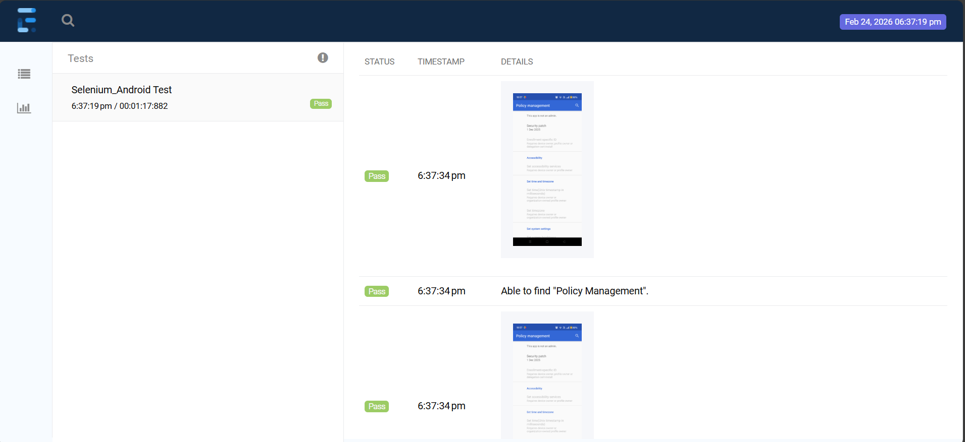
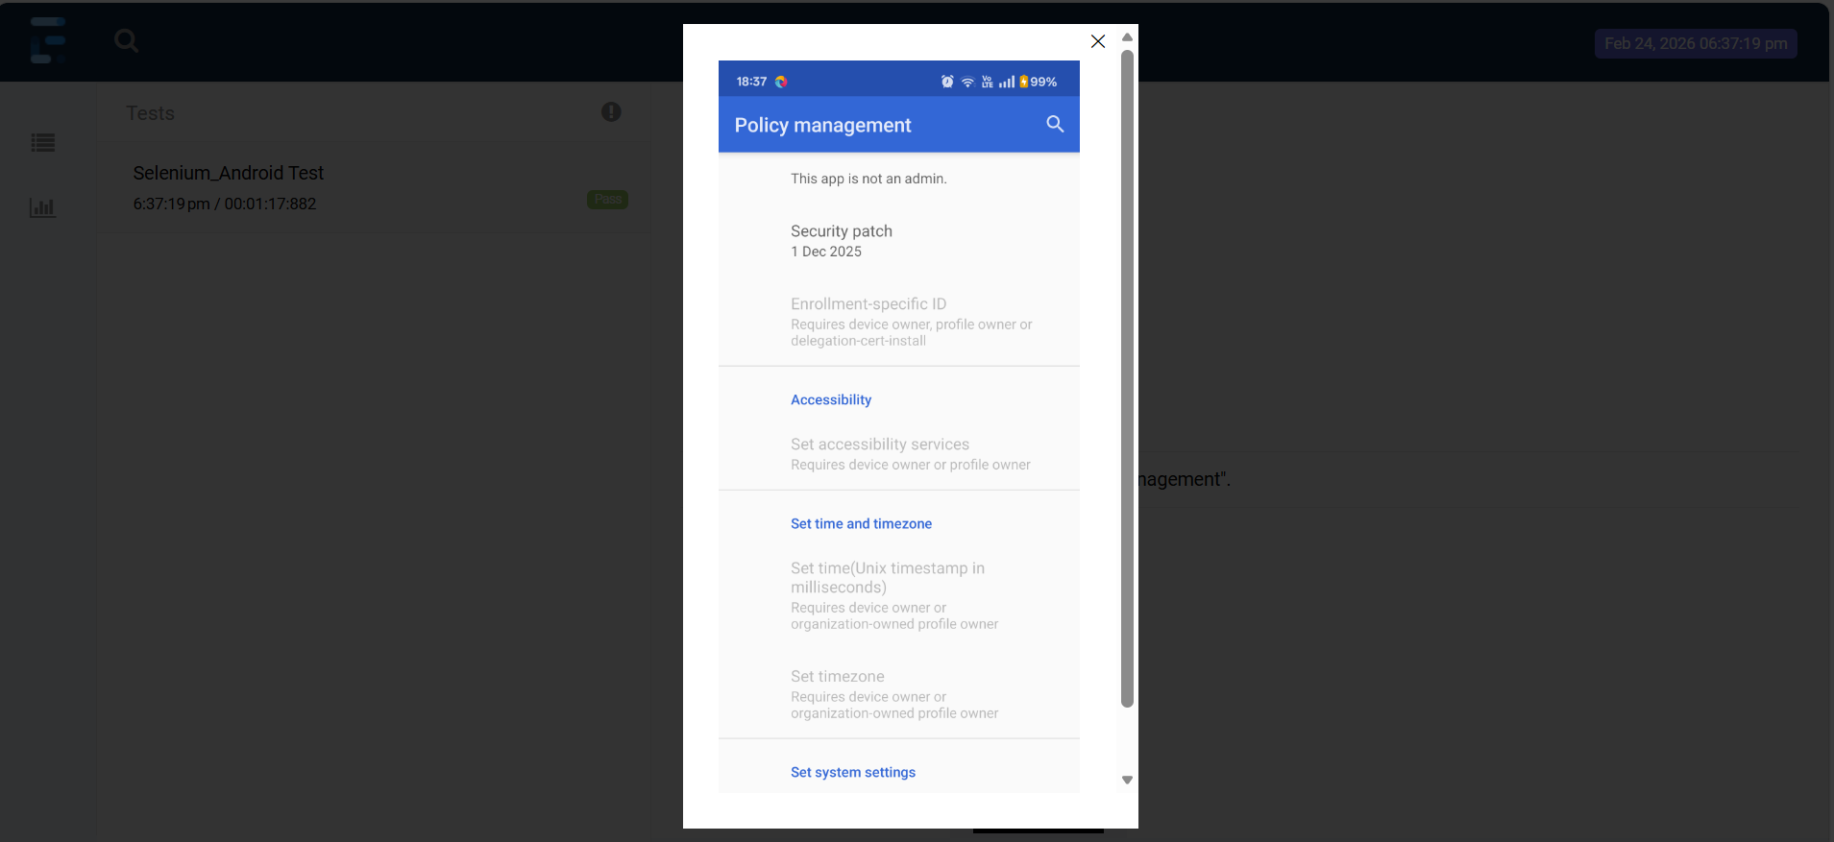

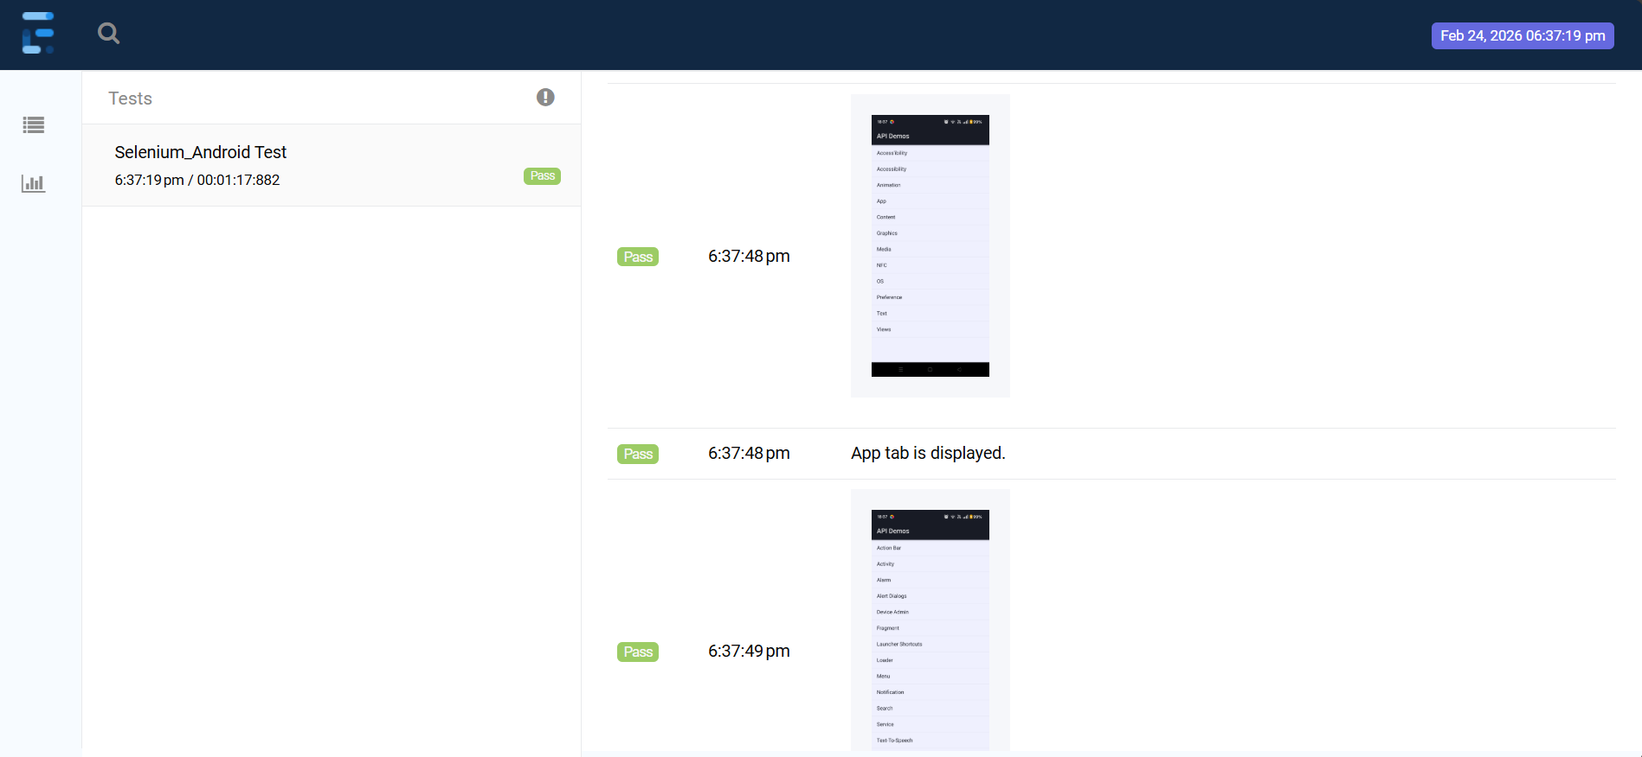

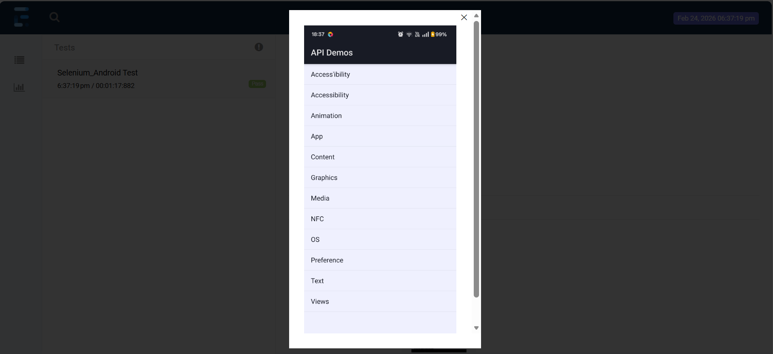

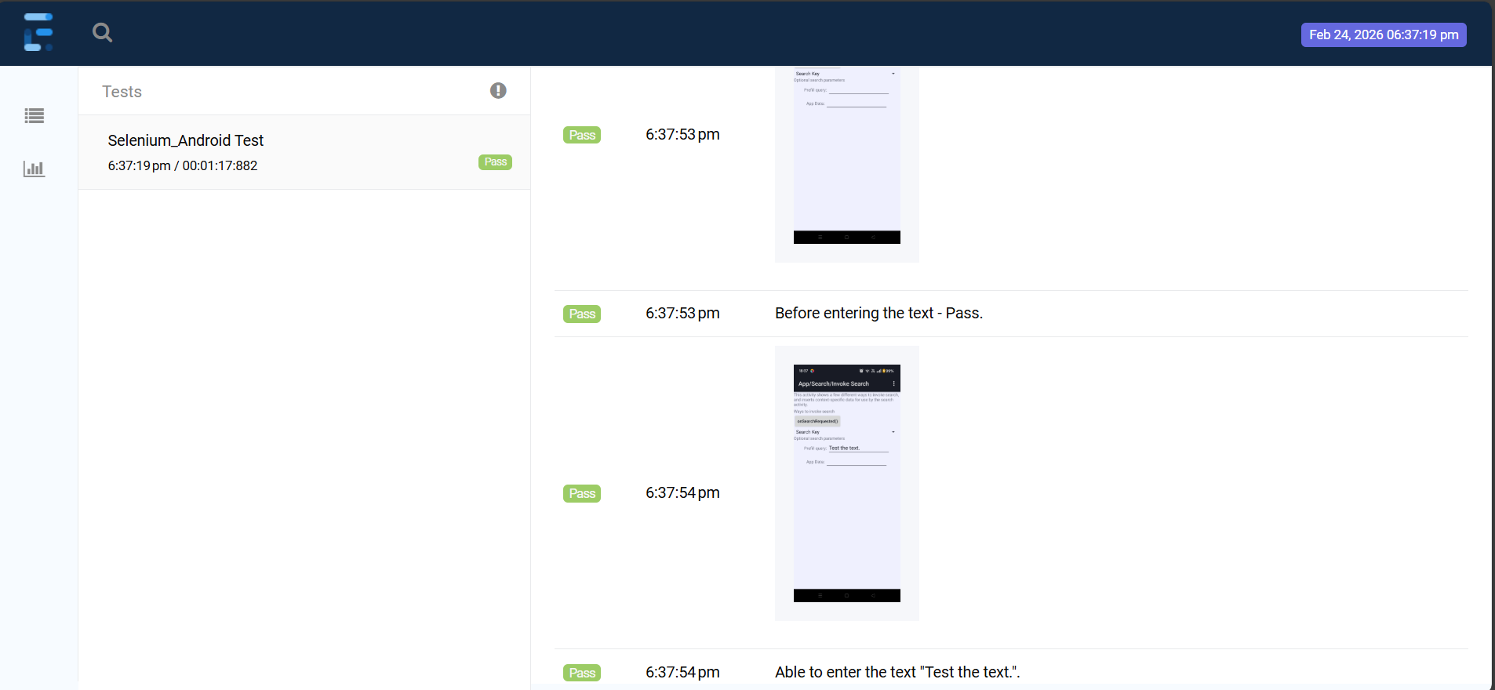

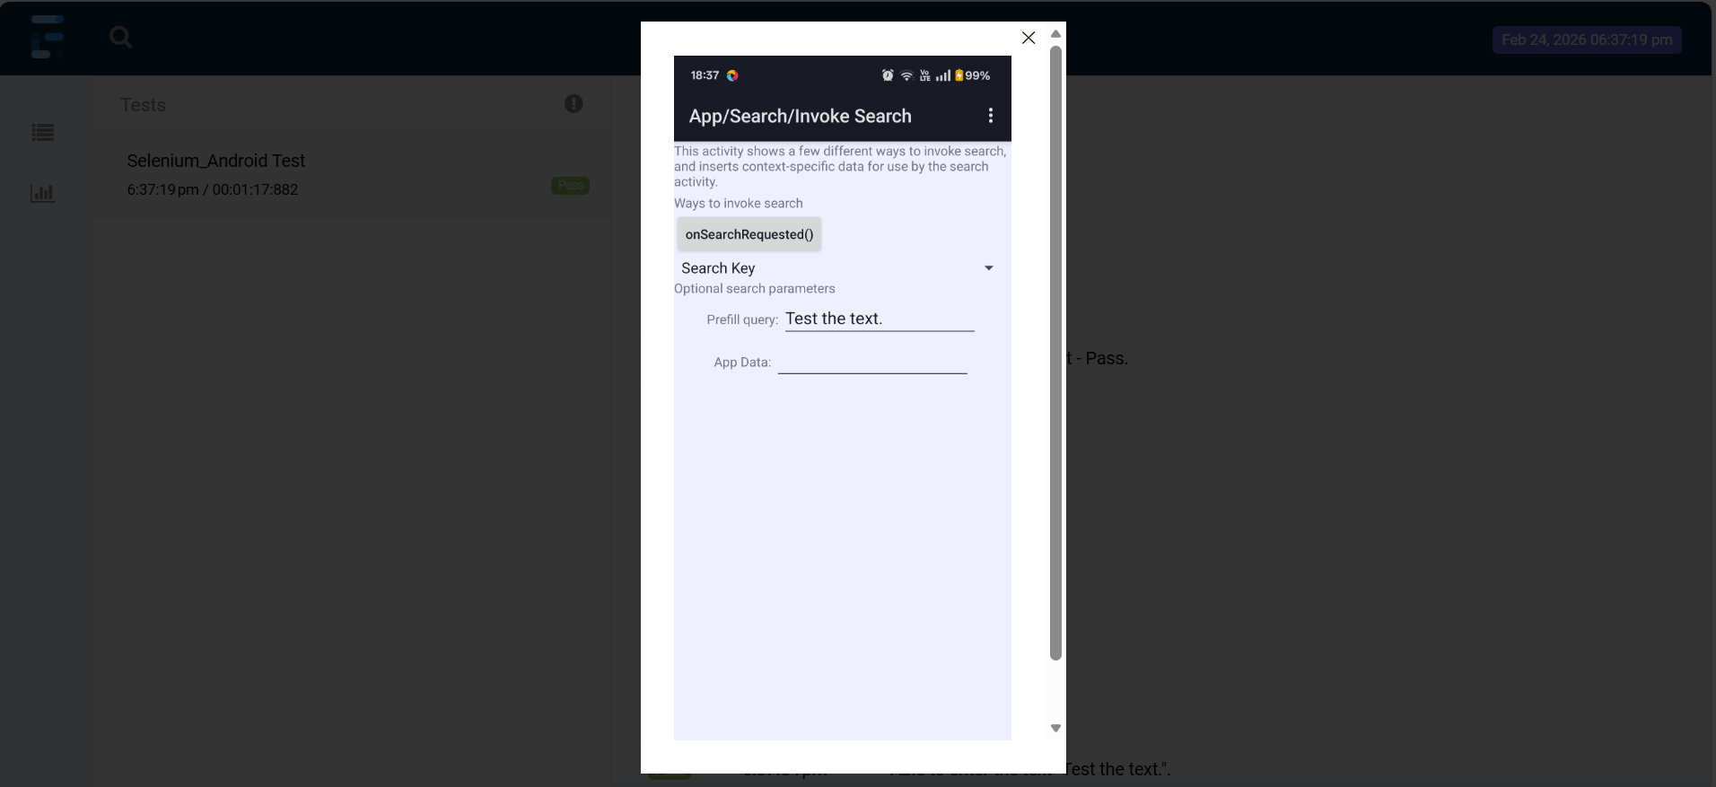

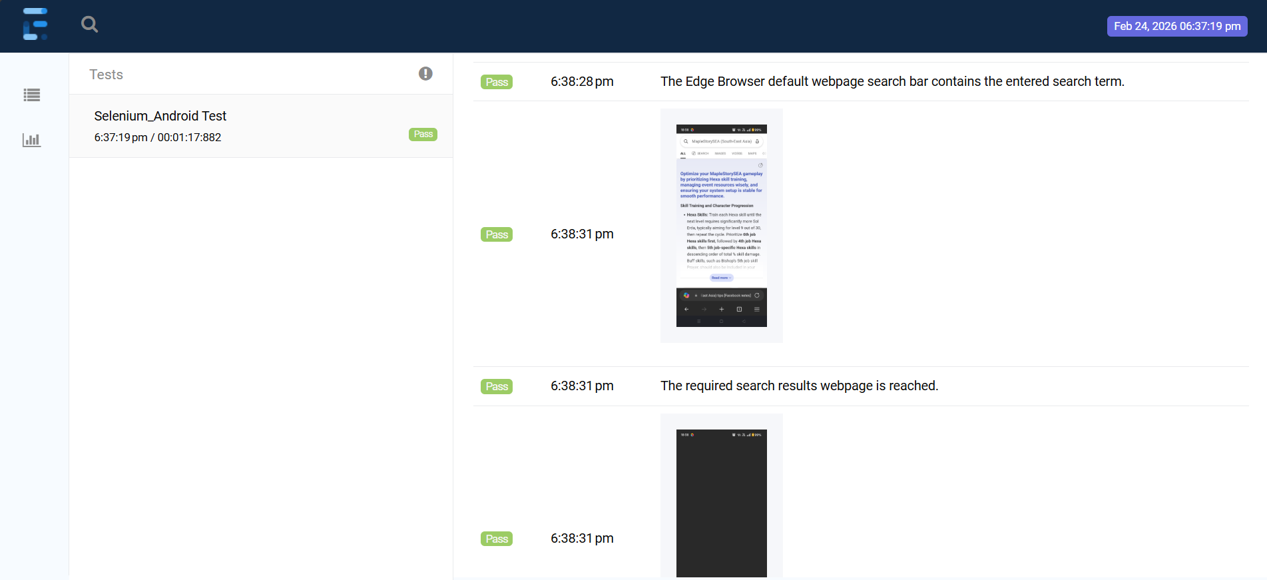

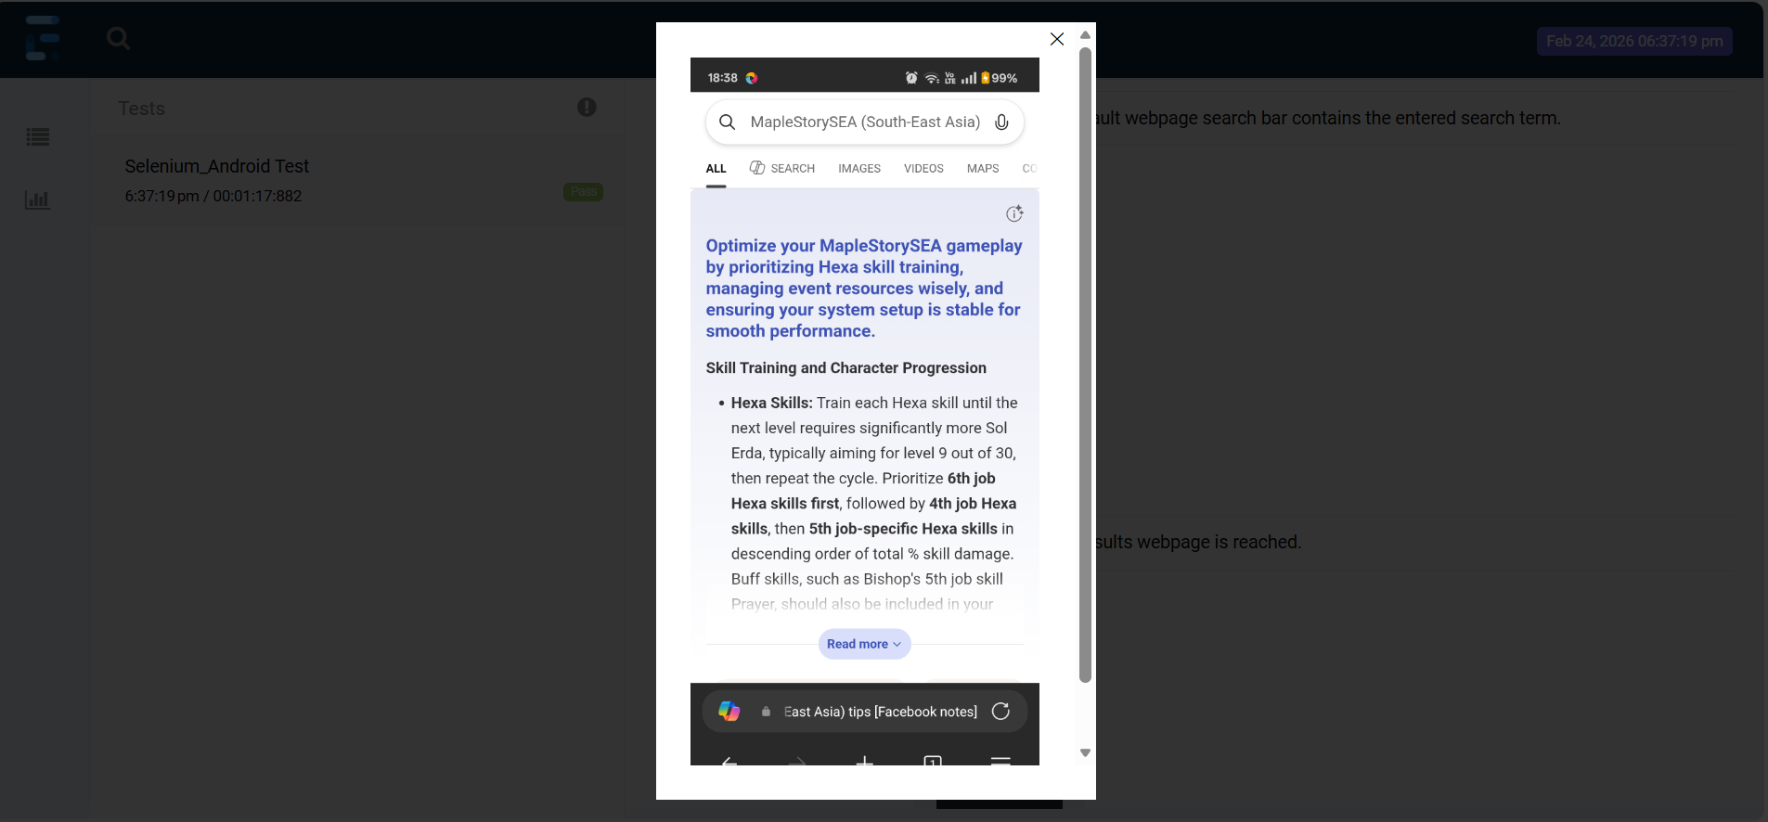

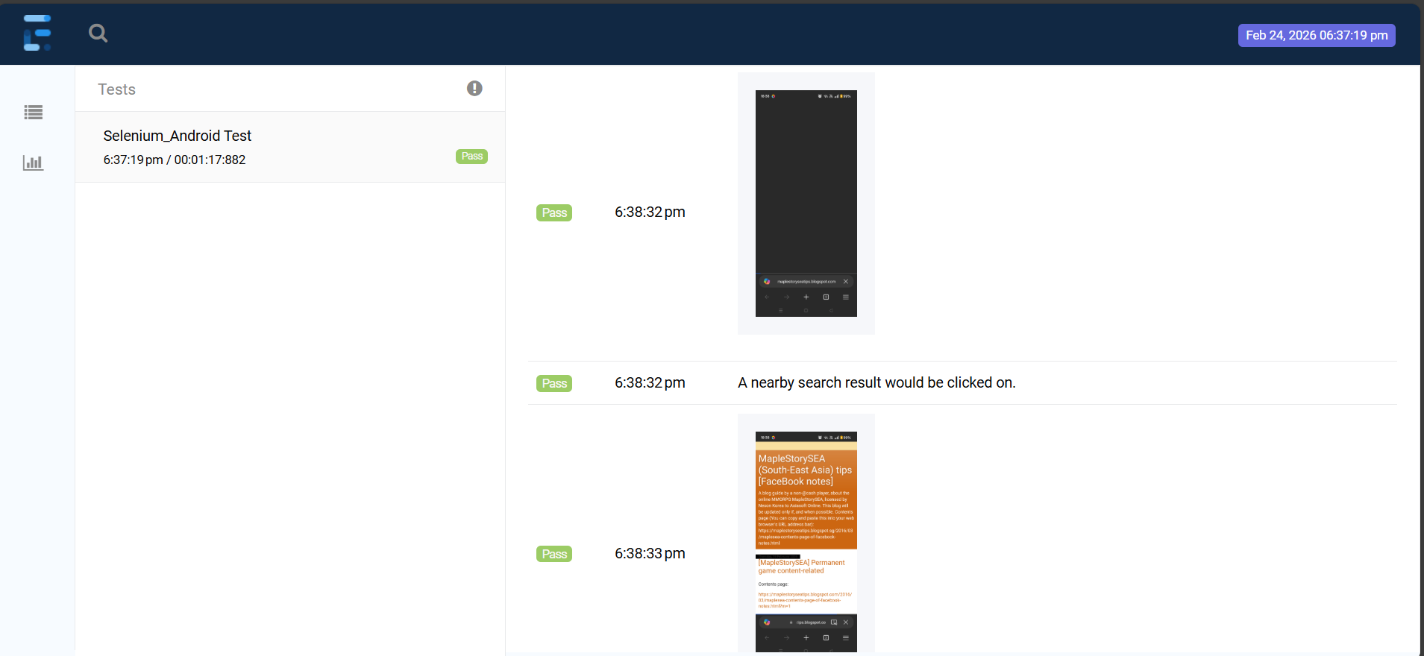

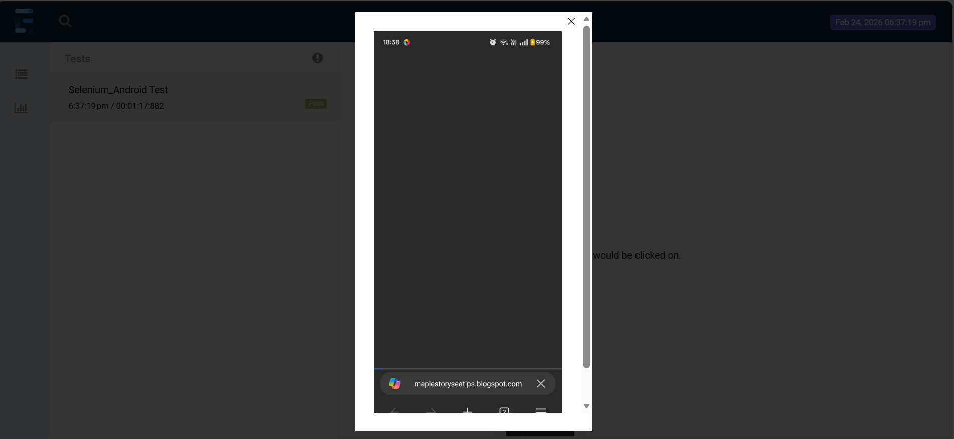

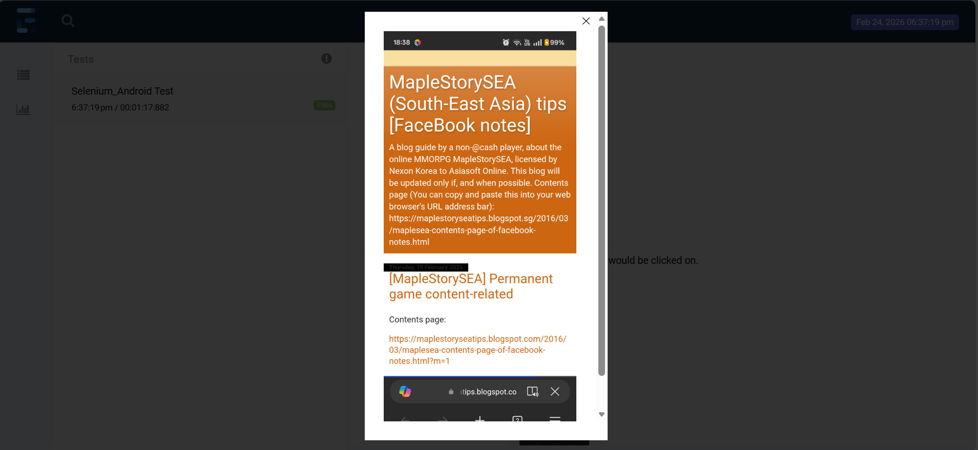

https://github.com/appium/appium-inspector?tab=readme-ov-file

https://inspector.appiumpro.com/

The next two screenshot images (which are not provided above) do not display the above screenshot image’s webpage, so they can be ignored. This is due to waiting for more than the required amount of time to reach a nearby Microsoft Bing search results webpage’s partialLinkText, which cannot be the correct partialLinkText, Appium - Hybrid App WebElement identifiers do not work; but the Appium - Native App WebElement identifiers work, for IntelliJ IDEA with Java. Only the desktop Google Chrome web browser is able to click on the correct partialLinkText, and is able to use the other identifiers - id, className, and tagName.

Found that Webstorm with Python would open and close the third Android smartphone application as the application is not a Native App, as it is a Hybrid App.

Thank you.

